**SRI SIVASUBRAMANIYA NADAR COLLEGE OF ENGINEERING**

(AN AUTONOMOUS INSTITUTION, AFFILIATED TO ANNA UNIVERSITY, CHENNAI) RAJIV GANDHI SALAI (OMR), KALAVAKKAM - 603110

**LABORATORY RECORD**

**UIT1611 - WEB PROGRAMMING LABORATORY**

**Name Reg. No. Dept.**

: **Aditya R**

: **195002004**

: **Information Technology** Sem.: **VI** Sec.: **A**



ANNA UNIVERSITY

**BONAFIDE CERTIFICATE**

Certified that this is the bonafide record of the practical work done for the

................................................................................................................................ ab

by

Name.................................................................................................

Register Number....................................................................................

of Department of ...................................................................................

Sri Sivasubramaniya Nadar College of Engineering,

Kalavakkam, Chennai

during the academic year ....................................

Staff In-Charge Head

Department of ..........................

*Submitted for the University Examination held at*

*Sri Sivasubramaniya Nadar College of Engineering on ...............................*

Internal Examiner External Examiner

|  |  |  |  |  |  |  |
| --- | --- | --- | --- | --- | --- | --- |
| **INDEX**  Name: Aditya.R Reg. No. :195002004 Sem. : VI Sec. :A | | | | | | |
|  | | | |  | | |
| Ex.No. | Date of Expt. | Title of the Experiment | Page No. | | Signature of  the Faculty | Remarks |
| 1(a) | 02.02.2021 | HTML 4: Horizontal rule, Links, Image Insertion, Ordered and unordered list,  Internal hyperlinking, Meta, Simple table, Form, Frames, and Hotspot  creation | 1 | |  |  |
| 1(b) | 09.02.2021 | CSS 2: Types of CSS  (inline, internal and external), Selectors, Box model, Layout, and  Positioning | 1 | |  |  |
| 1(c) | 16.02.2021 | HTML 5: New Structural Elements, Audio, Video, Form creation, Canvas API,  SVG, and Geo location | 1 | |  |  |
| 1(d) | 23.02.2021 | CSS 3: Borders, Text effects, Animation, and  Transitions | 1 | |  |  |
| 2(a) | 02.03.2021 | HTML/DHTML form validation using Regular  Expression | 30 | |  |  |
| 2(b) | 02.03.2021 | HTML DOM Manipulation | 30 | |  |  |
| 3(a) | 09.03.2021 | Simple Calculator using AngularJS | 42 | |  |  |
| 3(b) | 09.03.2021 | Angular program to implement Components,  Service, and Controllers | 42 | |  |  |
| 3(c) | 09.03.2021 | Angular program to implement search to filter  items | 42 | |  |  |
| 4 | 16.03.2021 | Angular program for  navigation menu | 56 | |  |  |

|  |  |  |  |  |  |
| --- | --- | --- | --- | --- | --- |
| **INDEX**  Name: Aditya.R Reg. No. :195002004 Sem. : VI Sec. :A | | | | | |
| Ex.No. | Date of Expt. | Title of the Experiment | Page No. | Signature of the Faculty | Remarks |
| 5(a) | 23.03.2021 | Angular program to switch between layouts | 72 |  |  |
| 5(b) | 23.03.2021 | Angular JS Animations | 72 |  |  |
| 6 | 30.03.2021 | Angular Program to create form with real time updations -PHP | 83 |  |  |
| 7 | 06.04.2021 | Video player using  AngularJS | 95 |  |  |
| 8 | 06.04.2021 | Text editor using AngularJS | 99 |  |  |
| 9 | 13.04.2021 | Dynamic website using Node and Express. | 107 |  |  |
| 10 | 13.04.2021 | Web application using MEAN stack | 113 |  |  |
| 11 | 20.04.2021 | Chat application with  multiple rooms using Node and Express | 126 |  |  |
| 12 | 27.04.2021 | RESTful web service for calculator application | 132 |  |  |

**EX. No.1 APPLICATION IDENTIFICATION**

**Date:** 15/03/2022

**Aim**

To identify an application to design, build and deploy it as composite web application.

**1.Introduction:**

**1.1 Purpose:**

The purpose of the document is to present a detailed description of a personal portfolio website. This website also includes a Content Management System (CMS). It will explain the purpose and features of the system, the interfaces of the system, what the system will do, the constraints under which it must operate and how the system will react to external stimuli.

**1.2 Scope:**

This Software system will be a Content Management System for a personal portfolio. This system will be designed to maximize productivity by providing an interface to create, update or delete blog posts and the other sections of the portfolio, which would otherwise have to be performed manually.

More specifically, this system is designed to showcase the achievements, projects, skillset and personal information to a prospective employer. The software also could facilitate communication from the site visitors via e-mail. The system also provides a high-level interface through which the contents of the website and the blog could be created, edited or deleted easily.

**1.3 Objectives:**

The main objective of this project is to attract potential employers and other site visitors. It showcases the user’s skillset and achievements. The project will also enable the user to easily modify the contents and update the website from time to time by providing a Content Management System.

**1.4 Product Features:**

* Responsive Website which ensures that it could be used on any device irrespective of it’s screen size.
* Authentication to allow the user to login and edit the contents of the website.
* Blog form to easily add blog posts.
* Multiple theme modes (Dark mode and Light mode).
* Showcases all the latest projects done by the user.
* Ability to contact the user via Email.
* Displays all the user’s achievements and also the current resume.

**2. Functional Requirement:**

* Admin should be able to login and should be presented an interface to modify the contents of the website.
* Logged in admin should be able to add, remove or modify blog posts
* The website should be supported by any screen size and should have multiple theme modes.
* The website should always be able to link to the latest version of the user resume.
* The website should have a contact section which would be able to contact the user directly via e-mail.
* The website should have a section for testimonials.
* Visitors of the website should be able to view and share blog posts.

**3. Software Requirement:**

* HTML5,CSS
* MEAN STACK
* MONGO DB

**4. Use Case Diagram:**

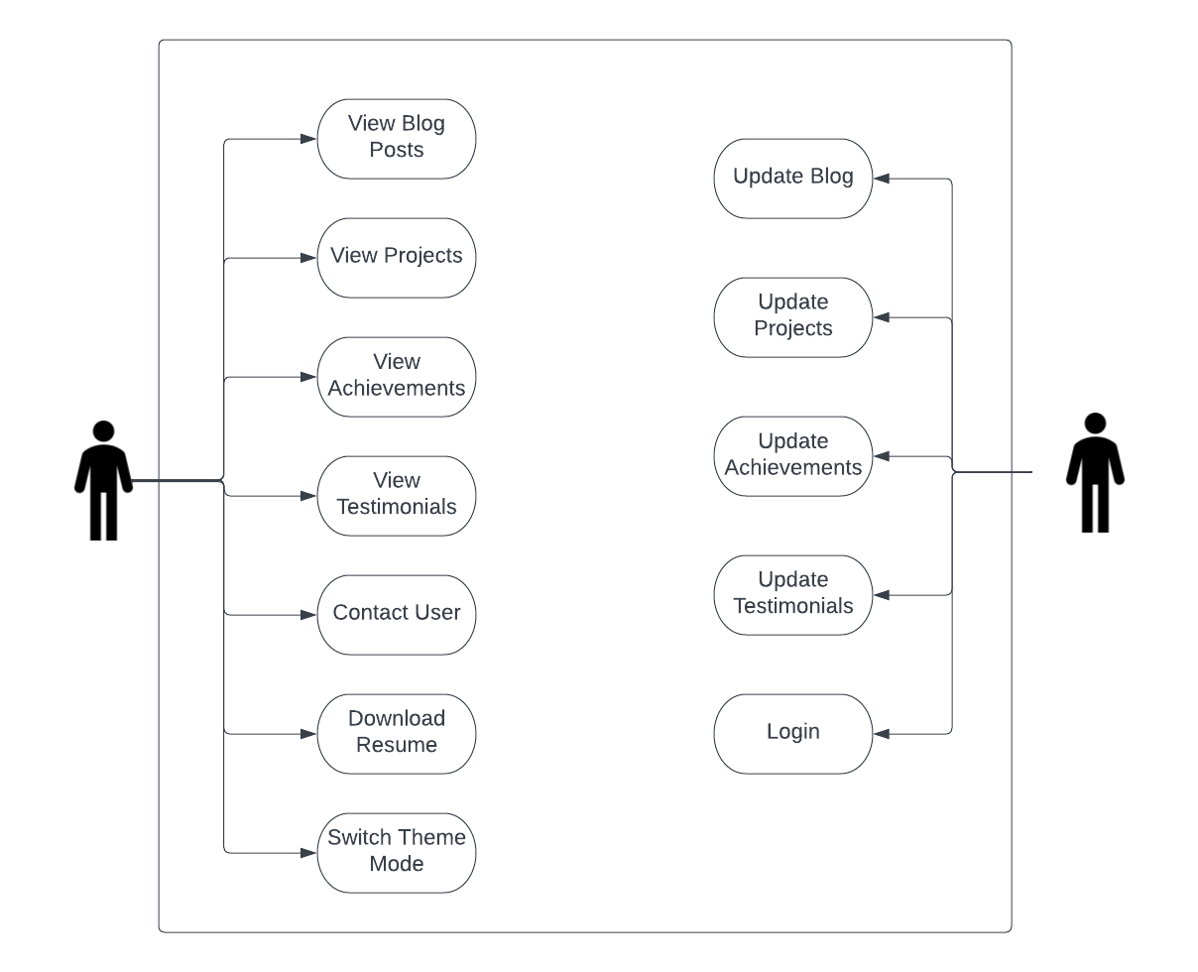

**5. Use Case Text:**

5.1

Use case :- Read Blog Posts

Actors :- Website Visitor

Overview:- Visitors could access and read all the blog posts posted by the author (administrator).

5.2

Use case :- View Projects, Achievements and Testimonials

Actors :- Website Visitor

Overview :- Visitors of this website could view all the owner’s achievements, their projects and also their testimonials.

5.3

Use case :- Switch Theme Mode

Actors :- Website Visitors and Administrator

Overview :-Could Switch the entire theme of the website according the user preference (light themed colors or dark themed colors).

5.4

Use case :- Contact User

Actor:- Website Visitor and Administrator

Overview:- Visitors could contact the website administrator directly from the website through e-mail.

5.5

Use case :- Download Resume

Actor:- Website Visitor

Overview:- The website visitors could download the latest version of the user’s resume directly from the website.

5.6

Use case :- Add, Remove or Update Blog Posts

Actor:- Administrator

Overview:- The administrator could easily add, remove or update the blog posts through a high level interface.

5.7

Use case :- Modify Achievements, Testimonials and Project Section

Actor:- Administrator

Overview:- The administrator could easily modify these sections of the website.

5.8

Use case :- Authentication

Actor:- Administrator

Overview:- The administrator could login or logout of the website.

**Result:** Thus the software requirement for portfolio and content management system is analyzed and documented successfully.

**EX. No.2a CREATION OF WEB PAGE USING HTML**

**Date:** 22/03/2022

**Aim**

To create a web page using HTML

**Algorithm:**

1. Text formatting tags is used

2. <table> tag with borders and proper spacing, spanning and padding is used

3. Use of <meta> tag is done

4. Using <a> tag to link web pages & Internal hyper linking

5. Ordered and unordered list is implemented

6. Including HTML 5.0 tags (Audio, Video, Form creation, Canvas API, SVG, and Geo location)

**Code:**

<!DOCTYPE html>

<html lang="en">

<head>

<meta charset="UTF-8">

<meta http-equiv="X-UA-Compatible" content="IE=edge">

<meta name="viewport" content="width=device-width, initial-scale=1.0">

<meta name="author" content="Aditya R">

<title>Html Demonstration</title>

<style>

li {

font-size: 1.2em;

}

a{

color:blue;

}

</style>

</head>

<body>

<a id="top"></a>

The HTML <b>bold element</b> defines bold text, without any extra importance. While the <strong>strong

element</strong> defines text with strong importance.The content inside a strong element is typically displayed

in bold.<br />

Whenever a technical term, a phrase from another language, a thought, etc (usually the part of text in alternate

voice/mood) have to be displayed they are usually displayed in <i>italics</i>.<br />

The HTML <em>emphasis element</em> defines emphasized text. The content inside is typically displayed in italic.

Even Screen readers would pronounce the words with an emphasis, using verbal stress.<br />

The HTML <small>small element</small> defines smaller text.<br />

The HTML <mark>mark element</mark> defines text that should be marked or highlighted.<br />

The HTML <del>deleted element</del> defines text that has been deleted from a document.Browsers will usually strike

a line through deleted text.<br />

The HTML <ins>inserted element</ins> defines a text that has been inserted into a document.Browsers will usually

underline inserted text.<br />

Whenever a chemical formulae has to be displayed a <sub>Subscript</sub> Text could be used. For Eg:-

H<sub>2</sub>O<br />

Whenever footnotes or Powers of a mathematical equation has to be expressed <sup>Superscript</sup>Text could be

used.

For Eg:- NxNxN=N<sup>3</sup><br />

<h2>Time Table</h2>

<table border="5px" cellpadding="10" cellspacing="1">

<tr>

<th rowspan="2">Day/Time</th>

<th>1</th>

<th>2</th>

<th>3</th>

<th>4</th>

<th>5</th>

<th>6</th>

<th>7</th>

<th>8</th>

</tr>

<tr>

<td>8:15-9:15</td>

<td>9:15-10:15</td>

<td>10:30-11:30</td>

<td>11:30-12:20</td>

<td>12:20-1:20</td>

<td>1:20-1:30</td>

<td>1:30-2:30</td>

<td>2:30-3:30</td>

</tr>

<tr>

<th>MON</th>

<td>PCD-L</td>

<td>BDE</td>

<td>OE</td>

<td>Lunch</td>

<td>WP</td>

<td>Break</td>

<td colspan="2" align="center">English Lab</td>

</tr>

<tr>

<th>TUES</th>

<td>WP</td>

<td>ML-L</td>

<td>PCD-L</td>

<td>Lunch</td>

<td colspan="4" align="center">WP Lab</td>

</tr>

<tr>

<th>WED</th>

<td>OE</td>

<td>PCD-L</td>

<td>ML-L</td>

<td>Lunch</td>

<td>ISD</td>

<td colspan="3" align="center">PCD/ML-P</td>

</tr>

<tr>

<th>THURS</th>

<td>ML-L</td>

<td>ISD</td>

<td colspan="2" align="center">PCD/ML-P</td>

<td colspan="2" align="center">Lunch</td>

<td>BDE</td>

<td>Mentor</td>

</tr>

<tr>

<th>FRI</th>

<td>BDE</td>

<td>WP</td>

<td>ISD</td>

<td>Lunch</td>

<td>WP Lab</td>

<td>Break</td>

<td>OE</td>

<td>Club</td>

</tr>

</table>

<h2>Images and Map</h2>

<img src="shapes.png" alt="Basic Shapes" width="540px" height="370px" usemap="#shapesmap">

<map name="shapesmap">

<area shape="circle" coords="149,84,60" alt="Circle" href="https://en.wikipedia.org/wiki/Circle"

target="_blank">

<area shape="rect" coords="343,18,472,146" alt="Square" href="https://en.wikipedia.org/wiki/Square"

target="_blank">

<area shape="rect" coords="80,220,215,320" alt="Rectangle" href="https://en.wikipedia.org/wiki/Rectangle"

target="_blank">

<area shape="poly" coords="407,195,345,322,470,323" alt="Triangle" href="https://en.wikipedia.org/wiki/Triangle"

target="_blank">

</map>

<br />

<h2>Top 5 Richest People in the world</h2>

<ol>

<li>Elon Musk</li>

<li>Bernard Arnault</li>

<li>Jeff Bezos</li>

<li>Bill Gates</li>

<li>Gautam Adani</li>

</ol>

<h2>List of Popular Mobile Operating Systems</h2>

<ul>

<li>Android</li>

<li>iOS</li>

<li>Windows</li>

<li>Linux</li>

</ul>

<a href="#top">Go to Top</a>

</body>

</html>

**OUTPUT**

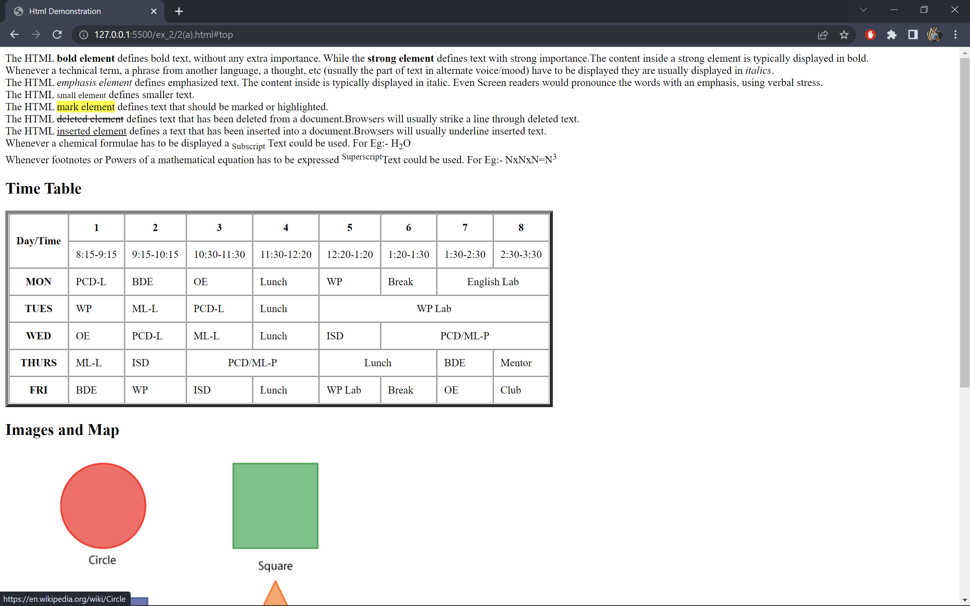

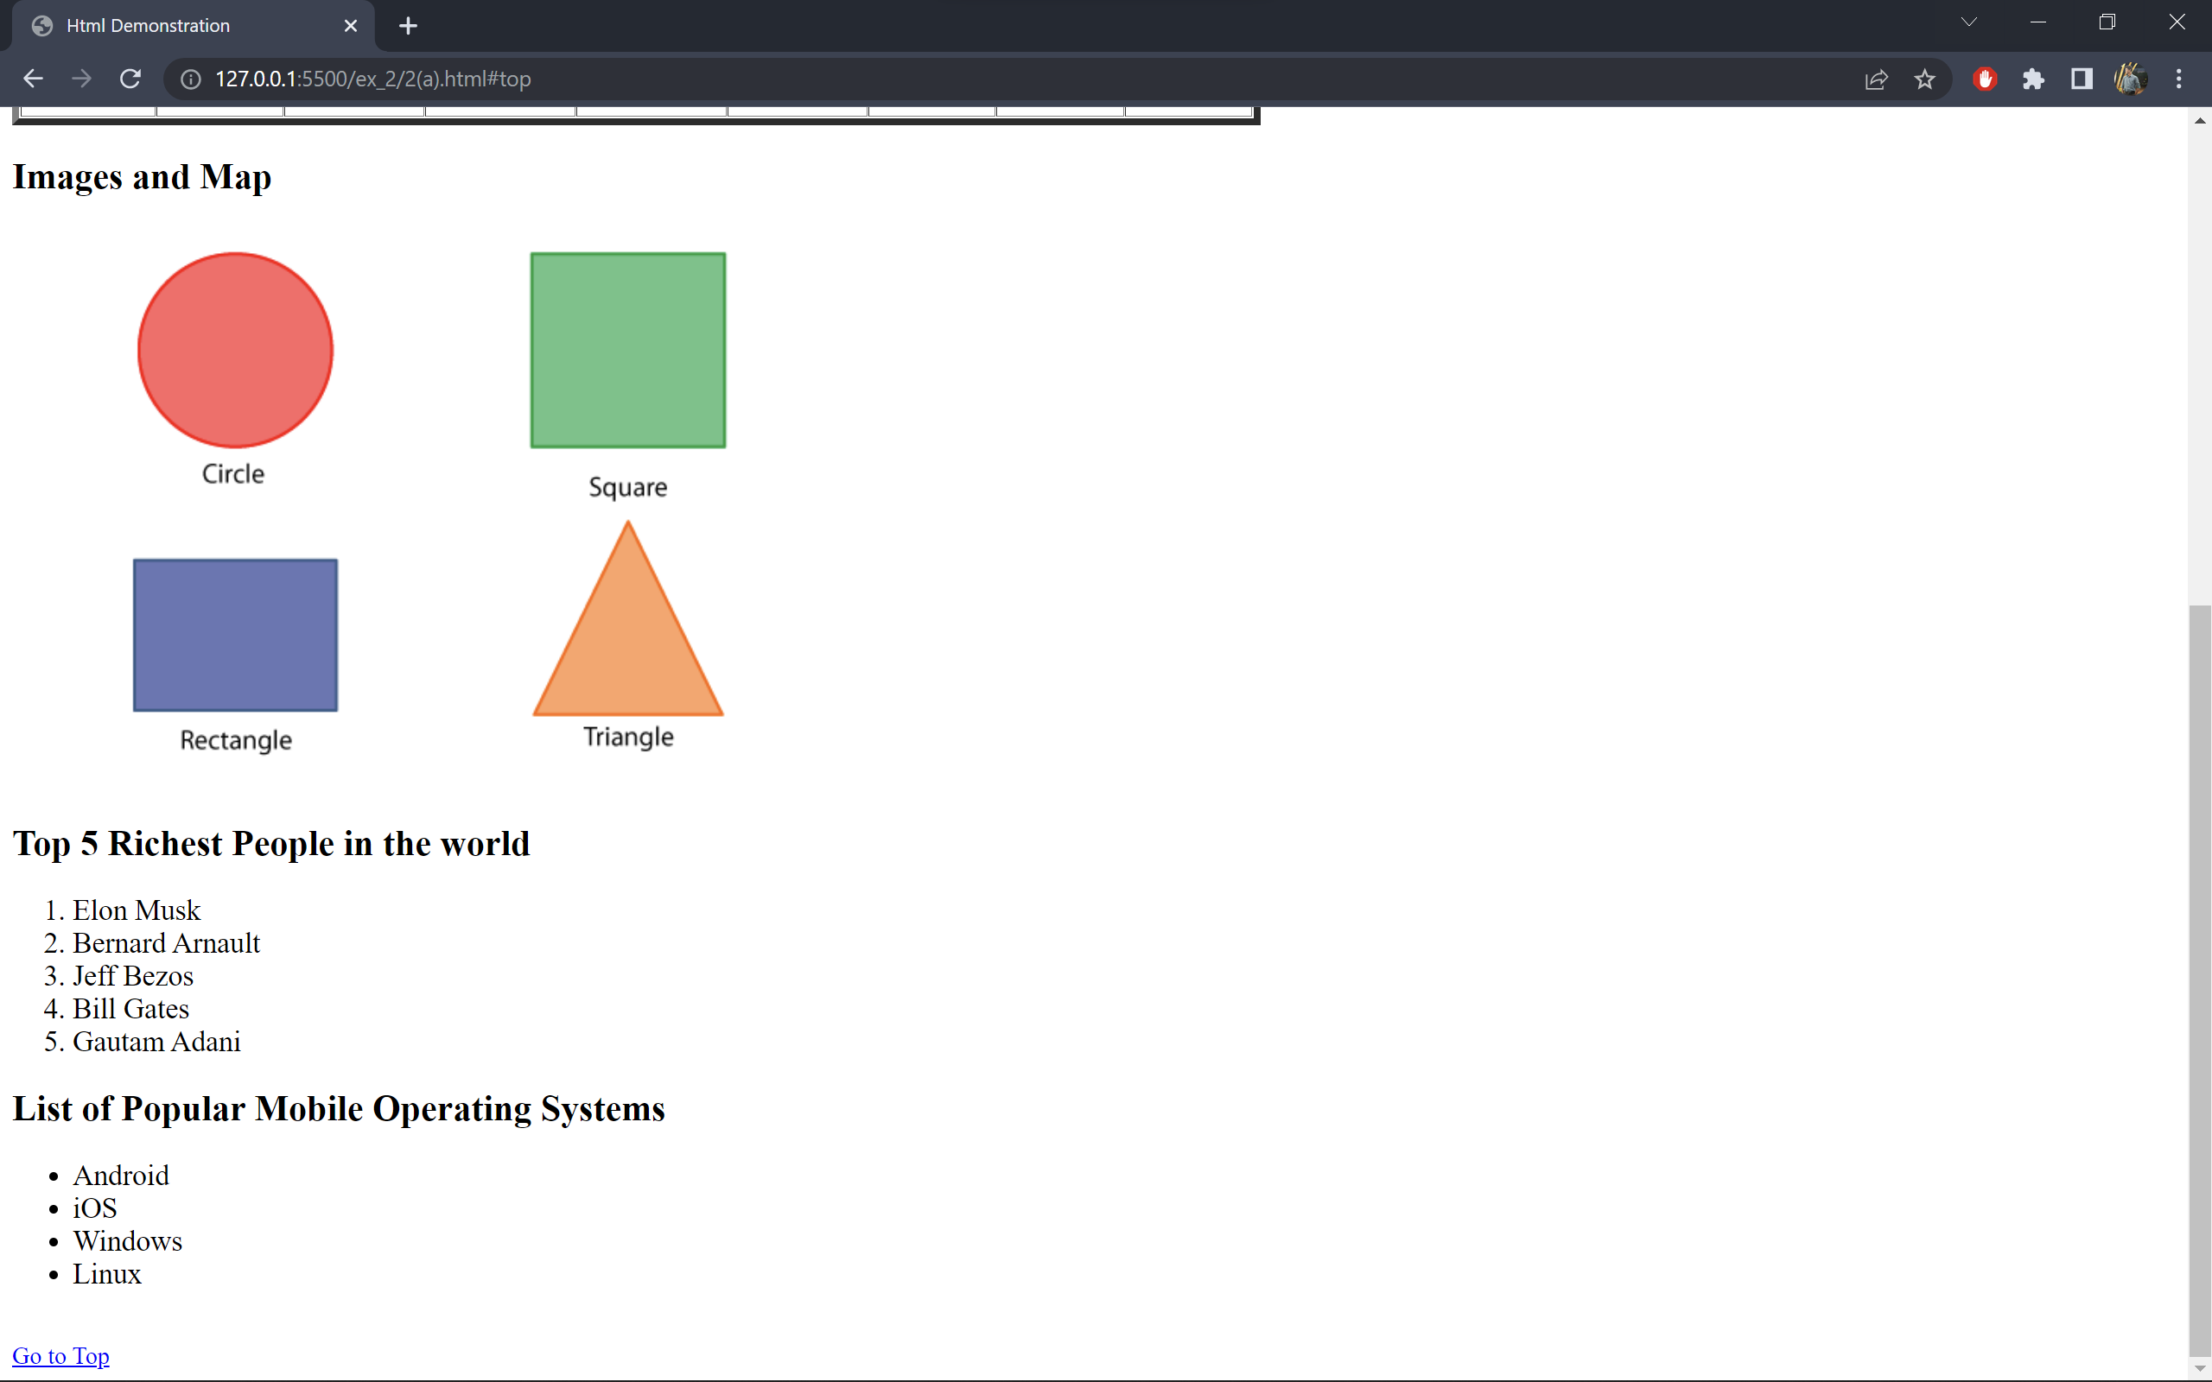

**2(b) Creation of web page using new structural elements ,audio, video, svg,canvas.**

**Date:** 22/03/2022

**Code:**

<!DOCTYPE html>

<html lang="en">

<head>

<meta charset="UTF-8">

<meta http-equiv="X-UA-Compatible" content="IE=edge">

<meta name="viewport" content="width=device-width, initial-scale=1.0">

<title>Html 5.0 Tags</title>

</head>

<body>

<h2>Audio</h2>

<audio controls>

<source

src="https://legitmuzic.com/wp-content/uploads/2021/09/Rick_Astley_-_Never_Gonna_Give_You_Up_legitmuzic.com.mp3"

type="audio/mpeg">

Your browser does not support the audio element.

</audio>

<h2>Video</h2>

<video width="320" height="240" controls>

<source src="https://download.samplelib.com/mp4/sample-5s.mp4" type="video/mp4">

Your browser does not support the video tag.

</video>

<h2>Canvas</h2>

<canvas id="myCanvas" width="200" height="100" style="border:1px solid #000000;">

</canvas>

<h2>SVG</h2>

<svg height="130" width="500">

<defs>

<linearGradient id="grad1" x1="0%" y1="0%" x2="100%" y2="0%">

<stop offset="0%" style="stop-color:rgb(255,255,0);stop-opacity:1" />

<stop offset="100%" style="stop-color:rgb(255,0,0);stop-opacity:1" />

</linearGradient>

</defs>

<ellipse cx="100" cy="70" rx="85" ry="55" fill="url(#grad1)" />

<text fill="#ffffff" font-size="45" font-family="Verdana" x="50" y="86">SVG</text>

Sorry, your browser does not support inline SVG.

</svg>

<h2>Location</h2>

<span id="location">

<button onclick="getLocation()">Get Location</button>

</span>

<script>

var c = document.getElementById("myCanvas");

var ctx = c.getContext("2d");

ctx.beginPath();

ctx.arc(95, 50, 40, 0, 2 * Math.PI);

ctx.stroke();

ctx.font = "30px Arial";

ctx.fillText("Hi", 80, 60);

var loc = document.getElementById("location");

function getLocation() {

if (navigator.geolocation) {

navigator.geolocation.getCurrentPosition(showPosition);

} else {

x.innerHTML = "Geolocation is not supported by this browser.";

}

}

function showPosition(position) {

loc.innerHTML = "Latitude: " + position.coords.latitude +

"<br>Longitude: " + position.coords.longitude;

}

</script>

</body>

</html>

**Output:**

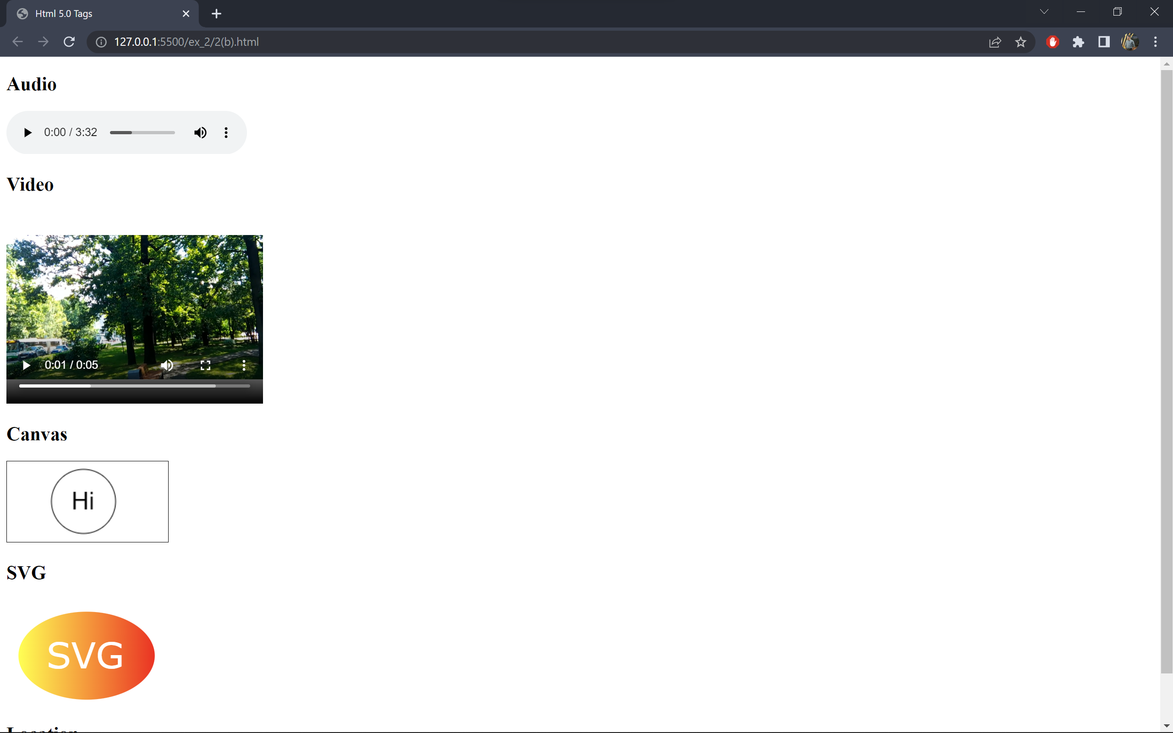

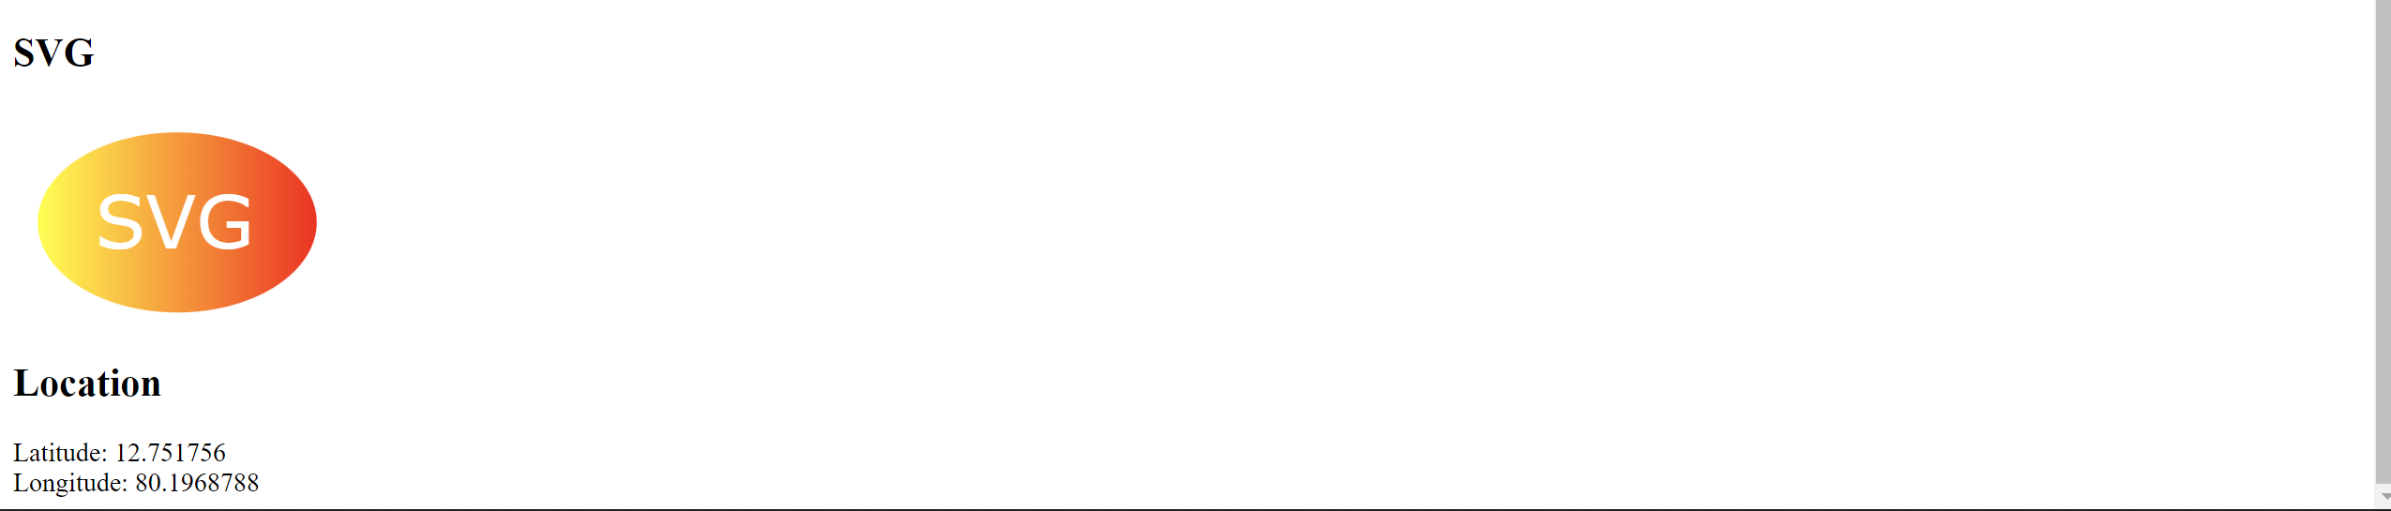

**Result:** Therefore the creation of html webpages using new structural elements, audio, svg, video and lists and tables tags is successfully implemented.

**EX. No.3 CASCADING STYLE SHEETS**

**Date:** 29/03/2022

**Aim**

Create a web page with all types of Cascading style sheets.

**Algorithm**

1.Create a html file

2.The inline css is implemented in the html file by using style attribute.

3.The internal css is implemented by declaring the css rules in script tag.

4.The external css is created in a file called style.css and linked to the html file using link tag.

**3(a) Inline Style:**

**Code:**

<!DOCTYPE html>

<html lang="en">

<head>

<meta charset="UTF-8">

<meta http-equiv="X-UA-Compatible" content="IE=edge">

<meta name="viewport" content="width=device-width, initial-scale=1.0">

<title>Inline Styles</title>

</head>

<body>

<p style="font-size: 2em;color:red;">

An <em>inline</em> style may be used to apply a unique style for a single element.

To use <em>inline</em> styles, add the style attribute to the relevant element.

The style attribute can contain any CSS property.

<em>Inline CSS</em> is considered useful as it reduces the number of files that the browser needs to download

before displaying the web page.With an external CSS, the browser first loads an HTML file and then downloads the CSS file.

With an <em>inline CSS</em>, you just need to download one HTML file instead of 2, making the process faster.

</p>

</body>

</html>

**Output:**

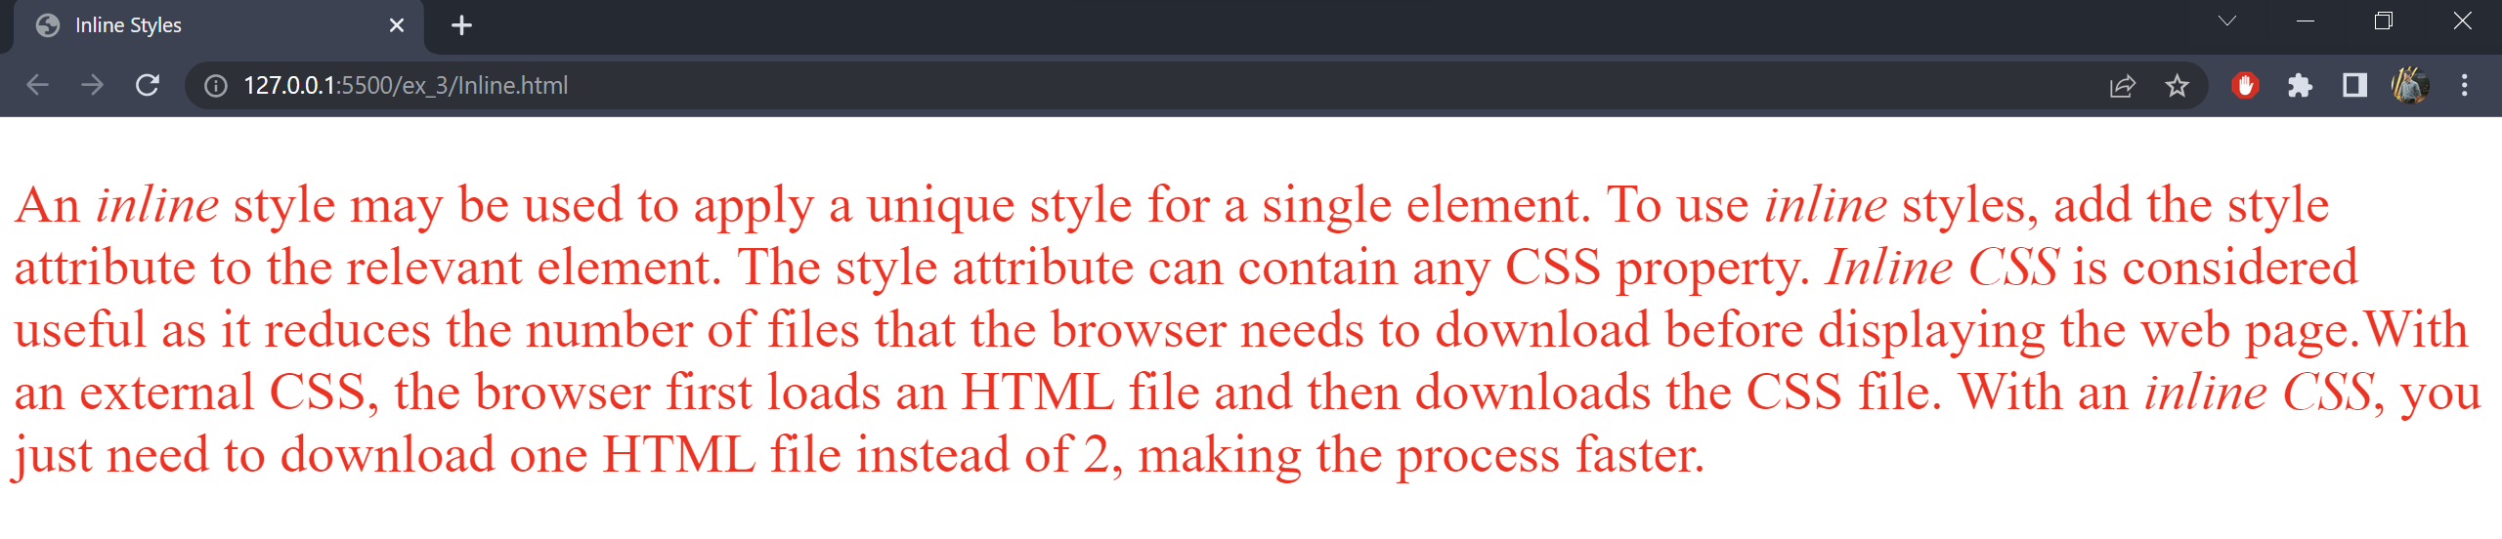

**3(b) Internal Style:**

**Code:**

<!DOCTYPE html>

<html lang="en">

<head>

<meta charset="UTF-8">

<meta http-equiv="X-UA-Compatible" content="IE=edge">

<meta name="viewport" content="width=device-width, initial-scale=1.0">

<title>Internal Style</title>

<style>

h1 {

color: blue;

}

.box-style {

font-size: 22px;

}

.box-style a {

color: blue;

text-decoration: none;

}

.box-style a:hover {

background-color: yellow;

}

</style>

</head>

<body>

<h1>Internal CSS Tutorial</h1>

<div class="box-style">

<p>Internal CSS is one of the most widely used CSS forms for changing, styling, and modifying the unique styles

of a single web page.You can use the internal CSS by integrating the &ltstyle&gt element in the &lthead&gt

section of a HTML web page.

All the changes done by the internal CSS can be applied only to a single web page.

You can use internal CSS for one-page websites or projects where you do not want to use external CSS. </p>

<h2>Conclusion</h2>

<p>

Internal CSS is only beneficial for single-page HTML websites. If you use internal CSS in your HTML web

page, you cannot reference this stylesheet to the &ltlink&gt elements. It can make the modification and

changes in a website more complex and challenging.

Internal CSS is not favorable for large projects where you are required to have more than one web page,

therefore the most common way to add CSS, is to keep the styles in external CSS files.

</p>

To learn more about CSS styles <a href="https://www.w3schools.com/html/html_css.asp" target="_blank">click

here</a>.

</div>

</body>

</html>

**Output:**

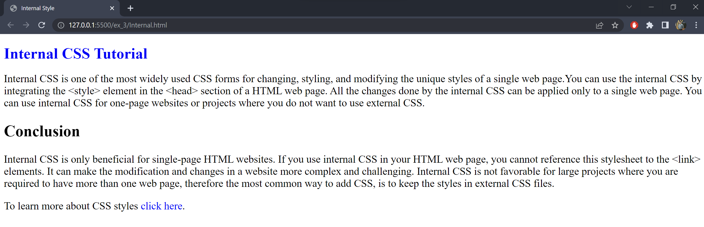

**3(c) External Styles:**

**index.html:-**

­ <!DOCTYPE html>

<html lang="en">

<head>

<meta charset="UTF-8">

<meta http-equiv="X-UA-Compatible" content="IE=edge">

<meta name="viewport" content="width=device-width, initial-scale=1.0">

<title>External Styles</title>

<link rel="stylesheet" href="style.css">

<script>

function toggleSidebar() {

var sidebar = document.getElementById("sidebar");

if (sidebar.style.width == "30%") {

sidebar.style.width = "0";

document.getElementById("sidebar-icon").innerHTML = "&#9776;";

} else {

sidebar.style.width = "30%";

document.getElementById("sidebar-icon").innerHTML = "&times;";

}

}

</script>

</head>

<body>

<span id="sidebar-icon" onclick="toggleSidebar()">&#9776;</span>

<div id="sidebar">

<h1>Sidebar</h1>

<p>

A website sidebar is a unique, creative, and useful component of website navigation design.

In most cases it is a column with typography, color palette, or icons and appears by the side of the main

content - either on the left or on the right, depending on the website layout and structure.

</p>

</div>

<div id="main-content">

<h1>External Style Sheets</h1>

<p>

To apply a rule to multiple pages, an external style sheet is used.

An <span class="highlighted-text">external style sheet</span> is a separate CSS file that can be accessed

by creating a link within the head

section of the webpage.

</p>

<p>

Multiple webpages can use the same link to access the stylesheet.The link to an <span

class="highlighted-text">external style sheet</span> is

placed within the head section of the page.

</p>

<span class="highlighted-text">External style sheets</span> have the following advantages over internal and

inline styles:

<ul>

<li>One change to the style sheet will change all linked pages</li>

<li>You can create classes of styles that can then be used on many different HTML elements</li>

<li>Consistent look and feel across multiple web pages</li>

<li>Improved load times because the css file is downloaded once and applied to each relevant page as needed

</li>

</ul>

To learn more about <span class="highlighted-text">external stylesheets</span> <a

href="https://www.javatpoint.com/external-css" target="_blank">click

here</a>.

</div>

</body>

</html>

**style.css:-**

a {

text-decoration: none;

}

a:hover {

text-decoration: underline;

text-decoration-color: #F0A04B;

color: #183A1D;

background-color: #E1EEDD;

}

li {

color: #f6C453;

font-weight: 600;

background-color: #FEFBE9;

margin-bottom: 8px;

}

ul {

margin-left: 2cm;

}

body {

background-color: #f9f9f9;

margin: 4px;

font-family: Verdana, Geneva, Tahoma, sans-serif;

}

#main-content {

width: 80%;

margin: auto;

padding: 12px;

border: 1px solid grey;

background-color: #f5f5f5;

}

h1,

h2,

h3,

h4,

h5,

h6 {

margin: 0;

color: orange;

}

p {

margin-bottom: 0.75em;

line-height: 1.5em;

}

#sidebar {

background-color: #FFEB2A;

width: 0;

z-index: 1;

overflow: hidden;

position: fixed;

height: 100%;

transition: 0.5s;

}

#sidebar-icon {

font-size: 36px;

cursor: pointer;

color: orange;

}

.highlighted-text {

background-color: yellow;

border: 1px solid #E78587;

padding: 1px 3px;

}

**Output:**

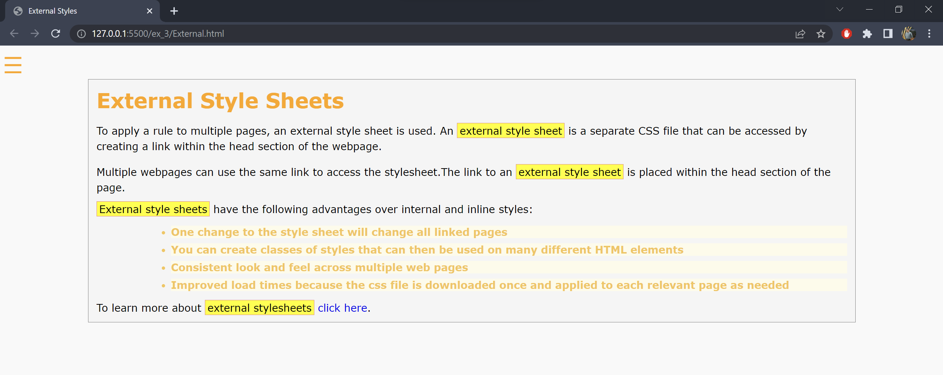

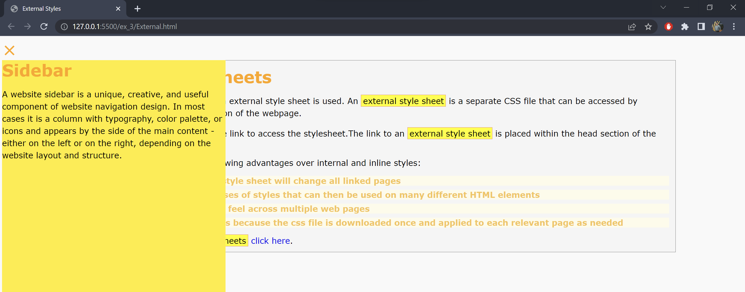

**Result:** Therefore the webpage with all types of cascading styles is implemented.

**Exercise 4(a)**

**Date:** 05/04/2022

**Aim**

To implement different programs and pages using Javascript.

**(i)** Write a Java Script that asks the user for a name, then greets the user with "Hello" followed by the user name on the page based on time.

**Code:**

<!DOCTYPE html>

<html lang="en">

<head>

<meta charset="UTF-8">

<meta http-equiv="X-UA-Compatible" content="IE=edge">

<meta name="viewport" content="width=device-width, initial-scale=1.0">

<title>Greeting Page</title>

<style>

div {

position: absolute;

top: 50%;

left: 50%;

transform: translateX(-50%) translateY(-50%);

color: orange;

font-size: 4em;

font-weight: 600;

}

</style>

<script>

var name = window.prompt("Enter your name: ");

var currentDate = new Date();

var currentHour = currentDate.getHours();

var greetingStr = "";

if (currentHour >= 6 && currentHour < 12) {

greetingStr = "Good Morning.";

}

else if (currentHour >= 12 && currentHour < 17) {

greetingStr = "Good Afternoon.";

}

else if (currentHour >= 17 && currentHour < 20) {

greetingStr = "Good Evening.";

}

else {

greetingStr = "Good Night.";

}

document.write("<div>Hello " + name + ", " + greetingStr + "</div>");

</script>

</head>

<body>

</body>

</html>

**Output:**

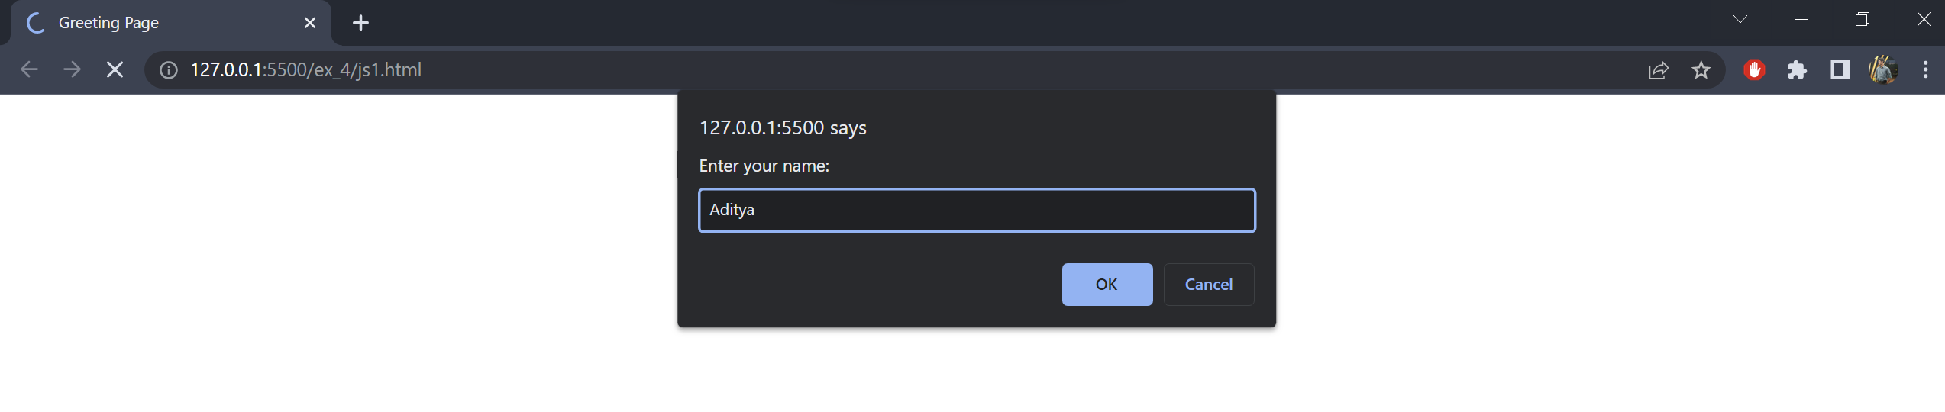

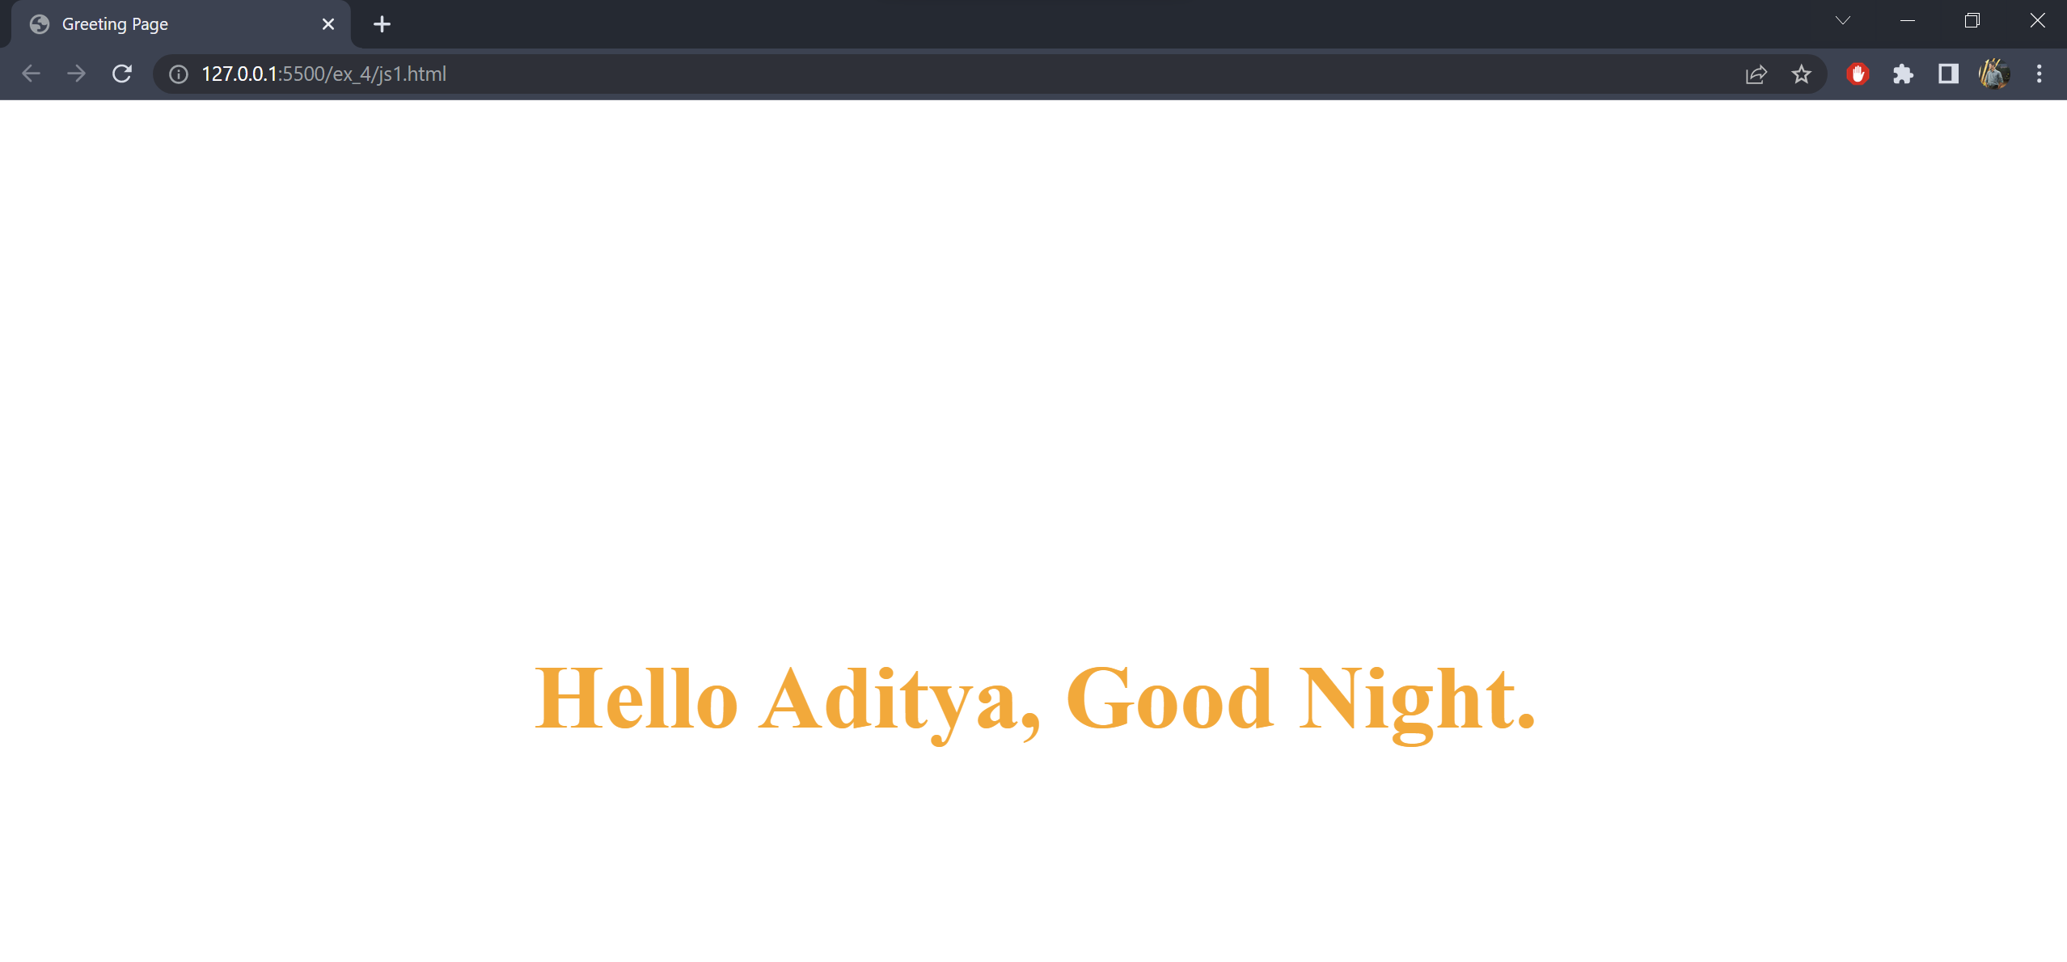

**(ii)** Write a Java Script that collects the numbers from a page and then adds them up and prints them to a blank field on the page.

**Code:**

<!DOCTYPE html>

<html lang="en">

<head>

<meta charset="UTF-8">

<meta http-equiv="X-UA-Compatible" content="IE=edge">

<meta name="viewport" content="width=device-width, initial-scale=1.0">

<title>Addition</title>

<style>

* {

font-family: 'Brush Script MT', cursive;

}

body {

color: #212121;

background-color: #FAB702;

margin: auto;

text-align: center;

width: 50%;

}

::placeholder {

color: #212121;

font-weight: 500;

}

input {

width: 50%;

margin: 20px;

padding: 10px;

background-color: #FAB702;

border: medium solid #212121;

border-radius: 8px;

}

input:focus {

border: medium solid white;

}

.add-btn {

margin-top: 20px;

width: 50%;

padding: 10px;

color: #212121;

background-color: white;

border: medium solid white;

border-radius: 8px;

cursor: pointer;

}

.add-btn:hover {

color: white;

background-color: #212121;

border: medium solid #212121;

border-radius: 8px;

}

#result {

margin-top: 20%;

font-size: 2em;

font-weight: 800;

}

</style>

<script>

function add(n1, n2) {

var sum = Number(n1) + Number(n2);

document.getElementById("result").innerHTML = n1 + " + " + n2 + " = " + sum;

}

</script>

</head>

<body>

<h1>Addition</h1>

<form name="additionForm" onsubmit="add(n1.value,n2.value);return false;" method="post">

<input id="n1" type="number" placeholder="Enter the first number" required>

<input id="n2" type="number" placeholder="Enter the first number" required>

<br />

<button type="submit" class="add-btn">Add</button>

</form>

<div id="result">

</div>

</body>

</html>

**Output:**

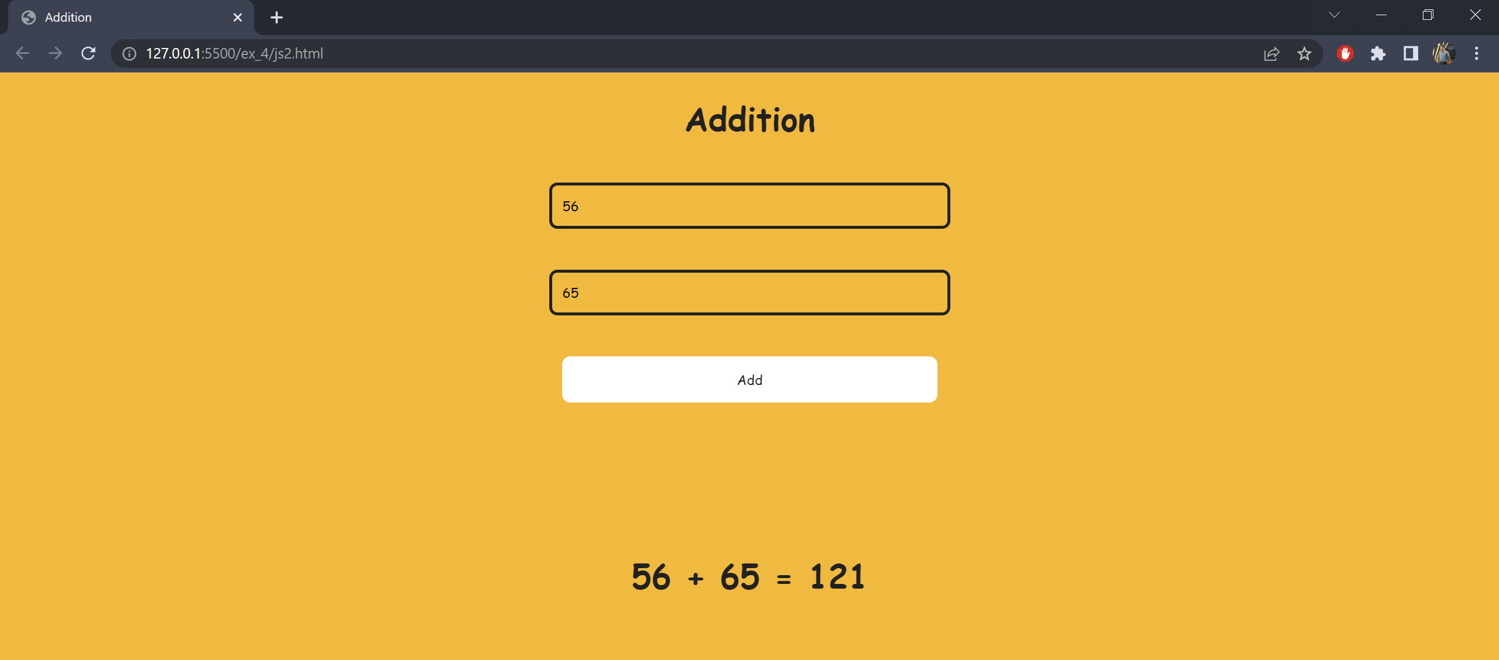

**(iii)** Write a Java Script that prompts the user for a number and then counts them from 1 to that number displaying only the odd numbers.

**Code:**

<!DOCTYPE html>

<html lang="en">

<head>

<meta charset="UTF-8">

<meta http-equiv="X-UA-Compatible" content="IE=edge">

<meta name="viewport" content="width=device-width, initial-scale=1.0">

<title>Odd Numbers</title>

<script>

var n = window.prompt("Enter the value of n");

var oddList = [];

for (var i = 0; i < n; i++) {

if (i % 2 == 1) {

oddList.push(i);

}

}

window.alert("The odd elements are " + oddList);

</script>

</head>

<body>

</body>

</html>

**Output:**

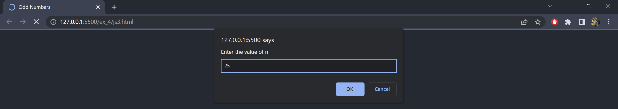

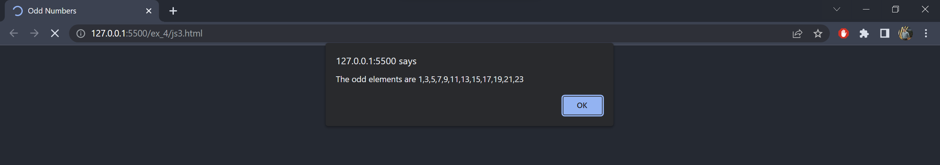

**(iv)** Write a Java Script to create a form with labels and submit button to provide feedback/hint to the user.

**Code:**

<!DOCTYPE html>

<html lang="en">

<head>

<meta charset="UTF-8">

<meta http-equiv="X-UA-Compatible" content="IE=edge">

<meta name="viewport" content="width=device-width, initial-scale=1.0">

<title>Feedback Form</title>

<style>

* {

font-family: 'Brush Script MT', cursive;

}

body {

color: #FAB702;

background-color: #212121;

margin: auto;

text-align: center;

width: 50%;

}

::placeholder {

color: white;

font-weight: 500;

}

h1 {

color: white;

}

input[type="text"],

select,

textarea {

color: white;

background-color: #212121;

padding: 10px;

margin: 30px 20px;

width: 50%;

border: medium solid white;

border-radius: 4px;

resize: none;

}

input[type="submit"] {

color: white;

background-color: #FAB702;

padding: 10px 20px;

border: none;

border-radius: 4px;

cursor: pointer;

}

input[type="reset"] {

color: white;

margin-left: 20px;

background-color: #212121;

border: none;

cursor: pointer;

}

</style>

</head>

<body>

<h1>Feedback Form</h1>

<form name="feedbackForm" onsubmit="validateForm()" method="post">

<label for="name">Name:</label><input id="name" name="name" type="text" placeholder="Enter your name" required

autofocus><br />

<label for="gender">Gender:</label>

<select id="gender" name="gender">

<option value="Male">Male</option>

<option value="Female">Female</option>

<option value="NaN">Prefer not to say</option>

</select><br />

<textarea placeholder="Enter your feedback here" rows="3" cols="3" required></textarea><br />

<input type="submit">

<input type="reset">

</form>

<script>

function validateForm() {

var name = document.forms["feedbackForm"]["name"];

window.alert("Hey " + name.value + ", thank you for giving us your valuable feedback!");

return false;

}

</script>

</body>

</html>

**Output:**

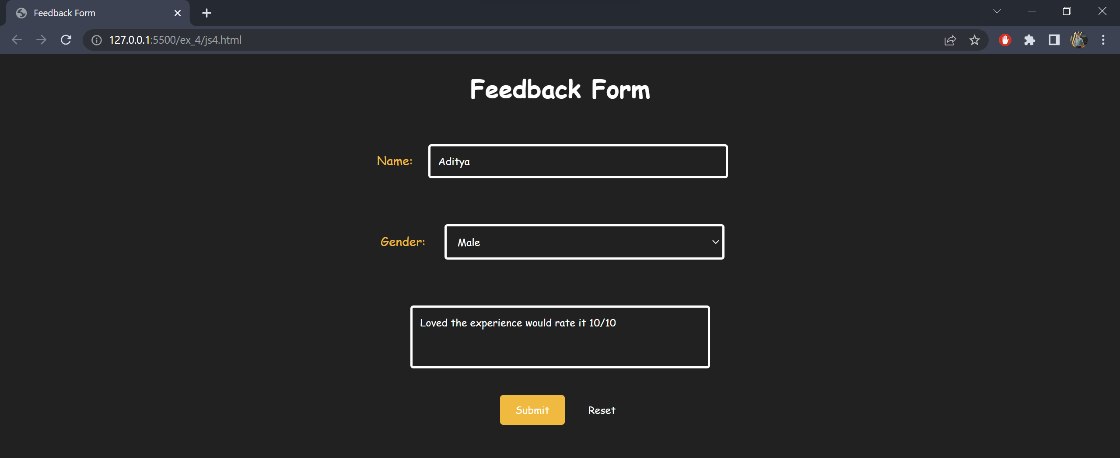

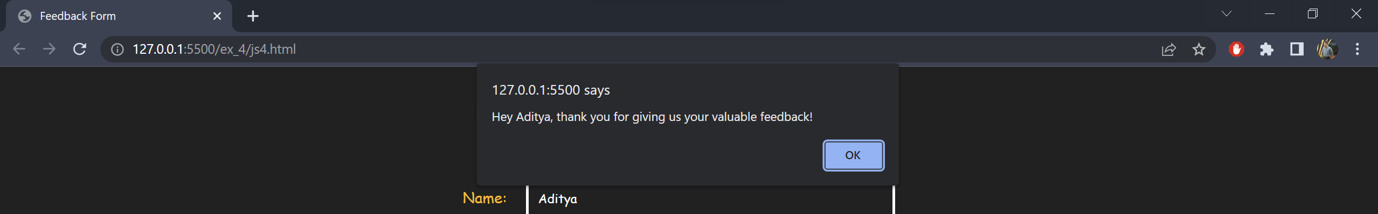

**(v)** Write a Java Script to create a form with a text box to ensure the field is not empty and have proper http:// else notify the user.

**Code:**

<!DOCTYPE html>

<html lang="en">

<head>

<meta charset="UTF-8">

<meta http-equiv="X-UA-Compatible" content="IE=edge">

<meta name="viewport" content="width=device-width, initial-scale=1.0">

<title>Feedback Form</title>

<style>

* {

font-family: 'Brush Script MT', cursive;

}

body {

color: #212121;

margin: auto;

text-align: center;

width: 50%;

}

::placeholder {

color: #212121;

font-weight: 500;

}

input {

color: #212121;

background-color: white;

padding: 10px;

margin: 30px 20px;

width: 50%;

border: medium solid #212121;

border-radius: 4px;

}

input[type="submit"] {

color: #212121;

background-color: #FAB702;

font-weight: 800;

padding: 10px 20px;

border: none;

border-radius: 4px;

cursor: pointer;

}

</style>

</head>

<body>

<form name="websiteForm" onsubmit="validateUrl()" method="post">

<label for="url-field">Enter the Url:</label><input id="url-field" name="url-field" type="url"

placeholder="http://www.example.com" required autofocus><br />

<input type="submit">

</form>

<script>

function validateUrl() {

var urlField = document.forms["websiteForm"]["url-field"];

if (urlField.value.startsWith("http://")) {

window.alert("Website submitted successfully");

return true;

}

else {

window.alert("Url should start with http://");

return false;

}

}

</script>

</body>

</html>

**Output:**

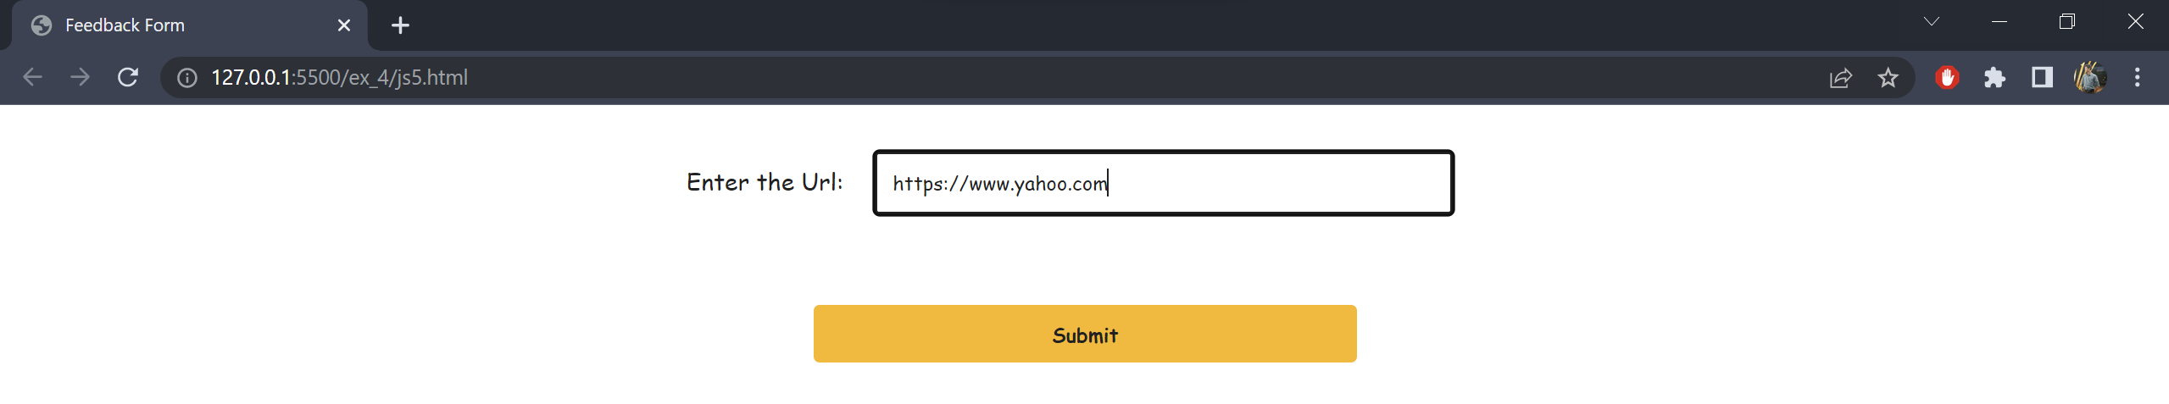

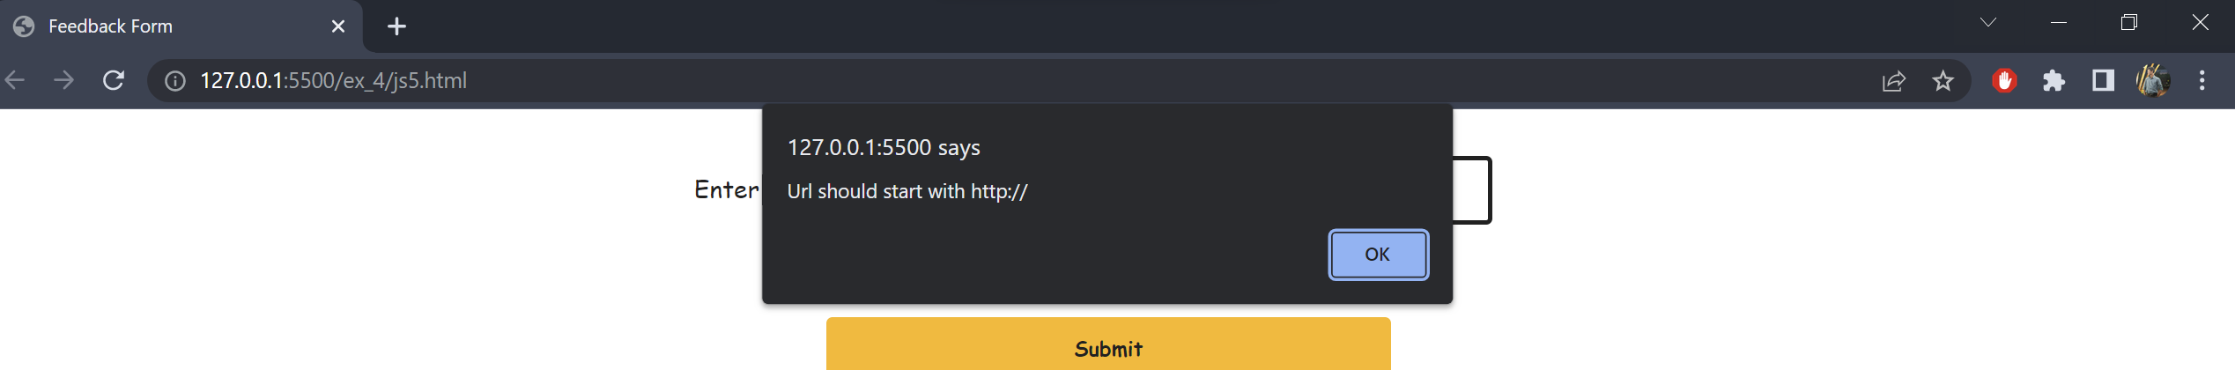

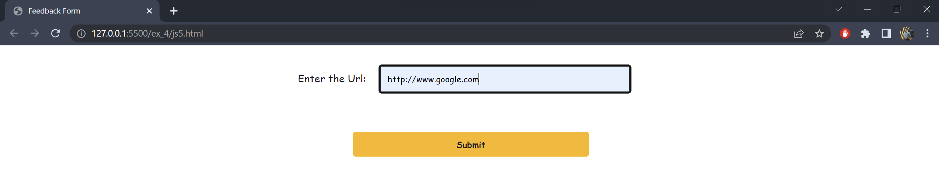

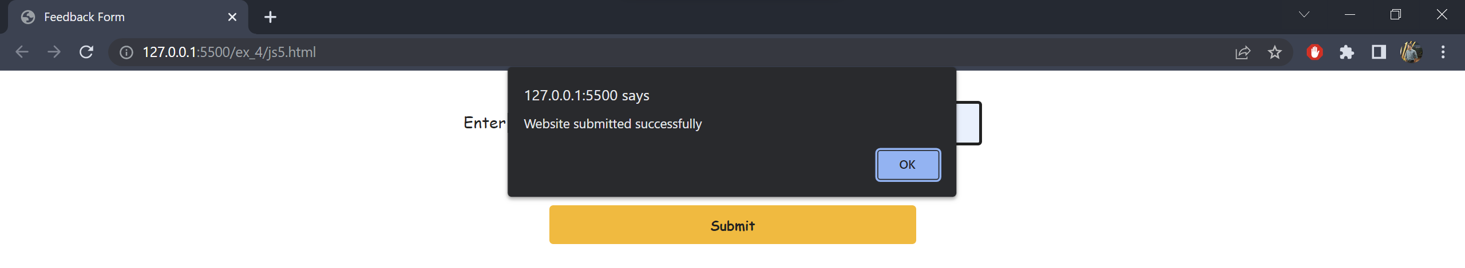

**Exercise 4(b)**

**Date:** 05/04/2022

**Aim**

To perform form validation using RegEx and javascript.

**Code:**

<!DOCTYPE html>

<html lang="en">

<head>

<meta charset="UTF-8">

<meta http-equiv="X-UA-Compatible" content="IE=edge">

<meta name="viewport" content="width=device-width, initial-scale=1.0">

<title>Log In</title>

<style>

* {

font-family: 'Brush Script MT', cursive;

}

body {

color: #212121;

background-color: #FAB702;

margin: auto;

text-align: center;

width: 50%;

}

::placeholder {

color: #212121;

font-weight: 500;

}

input {

width: 50%;

margin: 20px;

padding: 10px;

background-color: #FAB702;

border: medium solid #212121;

border-radius: 8px;

}

input:focus {

border: medium solid white;

}

input[type="submit"] {

margin-top: 20px;

width: 50%;

padding: 10px;

color: #212121;

background-color: white;

border: medium solid white;

border-radius: 8px;

cursor: pointer;

font-weight: 900;

}

input[type="submit"]:hover {

color: white;

background-color: #212121;

border: medium solid #212121;

border-radius: 8px;

}

</style>

</head>

<body>

<h1>Log In to the Chat Rooms</h1>

<form name="loginForm" onsubmit="validateForm();return false;" method="post">

<input id="username" name="username" type="text" placeholder="Enter your username" required><br />

<input id="email" name="email" type="email" placeholder="Enter your email address (@chatroom.com)" required

pattern=".+@chatroom\.com"><br />

<input id="password" name="password" type="password" placeholder="Enter your password" minlength="6"

maxlength="20" required><br />

<input type="submit">

</form>

<script>

function validateForm() {

var username = document.forms["loginForm"]["username"];

var email = document.forms["loginForm"]["email"];

var password = document.forms["loginForm"]["password"];

var regUsername = /^[a-z\d]{5,12}$/i;

var regPassword = /^[#\w@_-]{6,20}$/;

if (!regUsername.test(username.value)) {

window.alert("Username must be between 5 to 12 characters and should be only lowercase.");

return false;

}

else if (!regPassword.test(password.value)) {

window.alert("Password can only contain @, _ and -");

return false;

}

else {

window.alert("Logged In successfully");

return true;

}

}

</script>

</body>

</html>

**Output:**

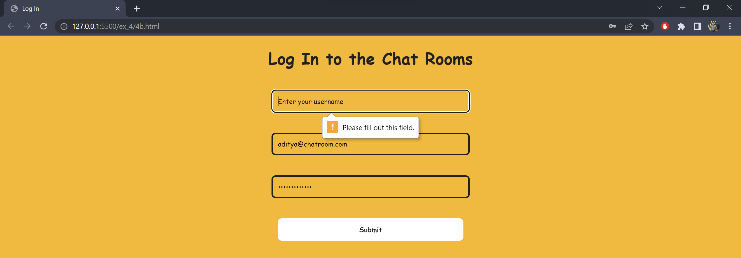

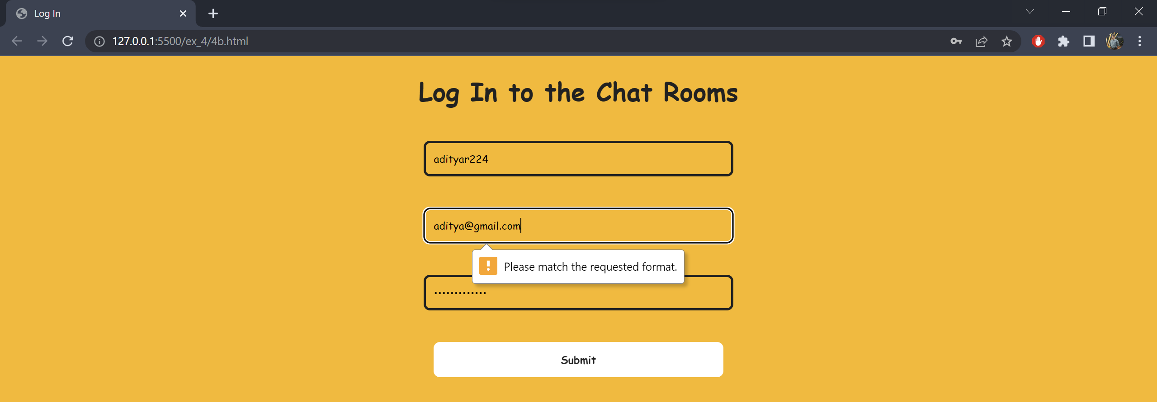

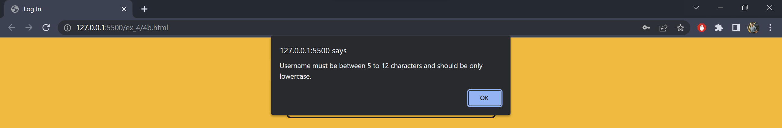

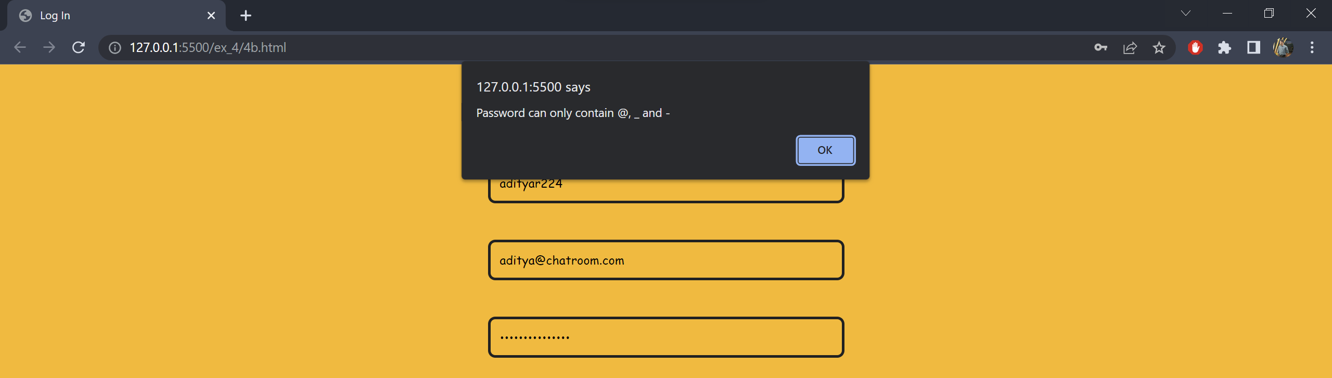

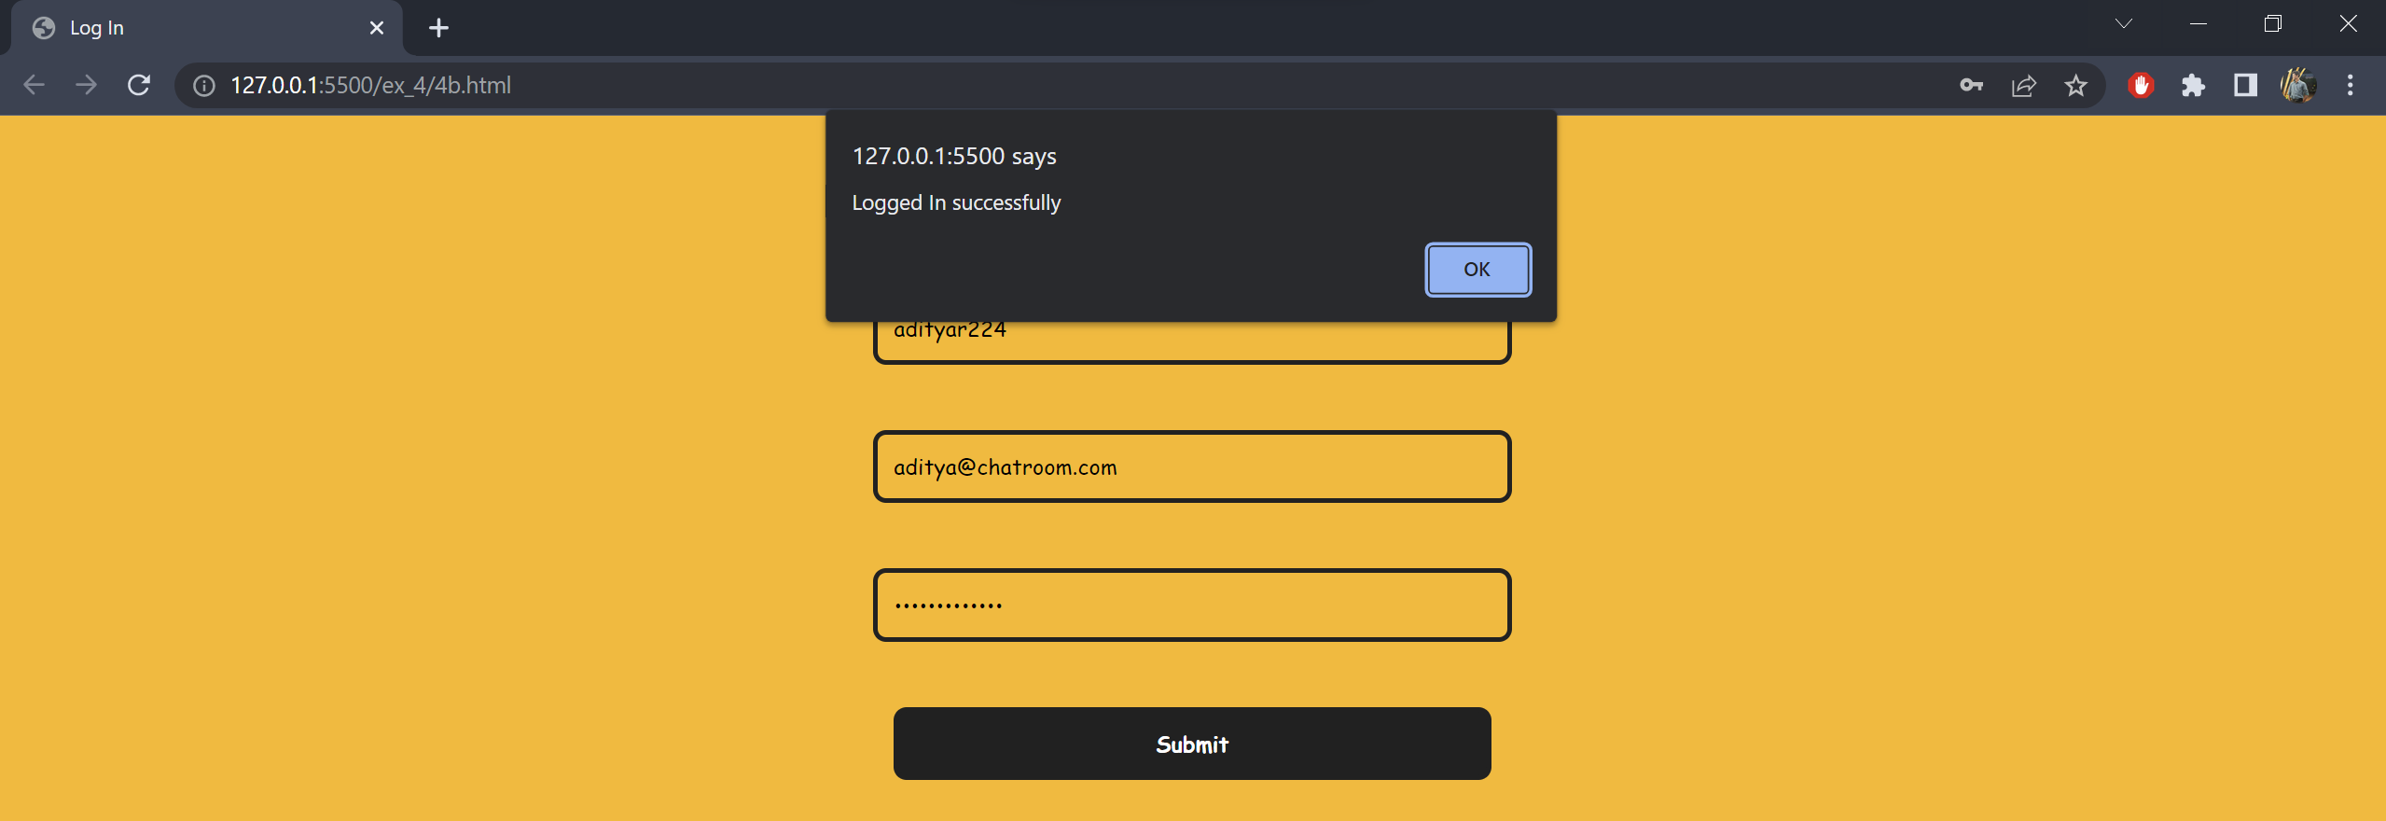

**Exercise 4(c)**

**Date:** 05/04/2022

**Aim**

To implement html DOM using javascript.

**(i)** Get a list of elements from the DOM

**Code:**

<!DOCTYPE html>

<html lang="en">

<head>

<meta charset="UTF-8">

<meta http-equiv="X-UA-Compatible" content="IE=edge">

<meta name="viewport" content="width=device-width, initial-scale=1.0">

<title>List all elements</title>

</head>

<body>

<h1>Heading h1</h1>

<p>Lorem ipsum dolor sit amet, consectetur adipiscing elit. Praesent sagittis augue ut tempor porta. Ut ullamcorper

viverra euismod. Phasellus eu odio purus. Etiam dapibus sit amet massa id eleifend. Suspendisse dapibus

tincidunt consequat. Vivamus dictum leo quis ipsum tempor, et pellentesque augue tempus. Etiam quis elementum

enim. In venenatis lectus tincidunt, suscipit ante at, malesuada justo. Maecenas congue dui rutrum rhoncus

varius. Maecenas eget sollicitudin diam. Pellentesque sed fermentum ligula, in pharetra metus. Quisque pharetra

hendrerit magna sed fringilla.

</p>

<script>

var nodesList = [];

document.querySelectorAll("*").forEach(function (node) {

nodesList.push(node.nodeName);

});

window.alert("All the elements are: " + nodesList);

</script>

</body>

</html>

**Output:**

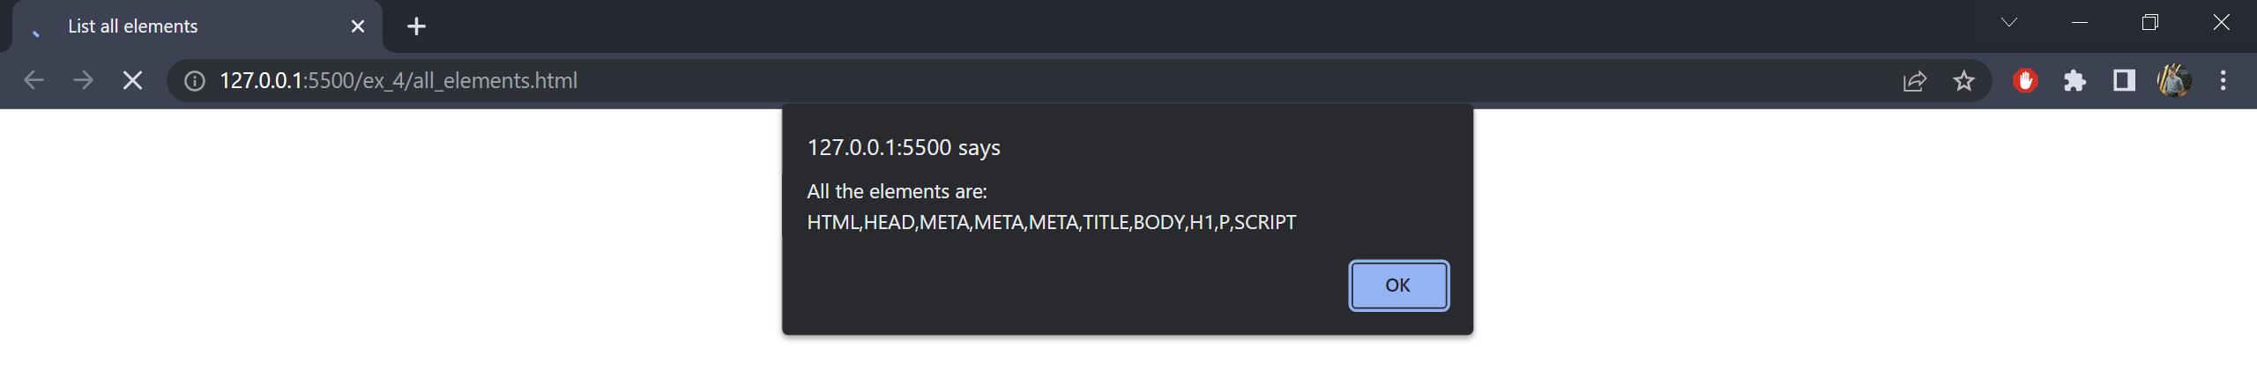

**(ii)** Manipulate - DOM tree.(Insert, Delete, Search and Display)

**Code:**

<!DOCTYPE html>

<html lang="en">

<head>

<meta charset="UTF-8">

<meta http-equiv="X-UA-Compatible" content="IE=edge">

<meta name="viewport" content="width=device-width, initial-scale=1.0">

<title>Dom Elements</title>

<style>

* {

font-family: 'Brush Script MT', cursive;

}

body {

color: #FAB702;

background-color: #212121;

margin: auto;

text-align: center;

}

ul {

list-style: none;

}

li {

font-size: 2em;

}

button {

color: white;

background-color: #FAB702;

padding: 10px 20px;

margin: 20px;

border: none;

border-radius: 4px;

cursor: pointer;

}

input {

color: white;

background-color: #212121;

padding: 10px;

margin: 30px 20px;

width: 15%;

border: medium solid white;

border-radius: 4px;

resize: none;

}

.input-with-icon {

position: relative;

display: inline;

}

.input-with-icon span {

position: relative;

left: 65px;

padding: 9px 8px;

}

.input-with-icon input {

padding-left: 35px;

}

</style>

</head>

<body>

<h1>Dom Manipulation</h1>

<button onclick="insertElement()">Insert</button>

<button onclick="deleteElement()">Delete</button><br />

<div class="input-with-icon">

<span>&#128269;</span>

<input id="n1" name="n1" type="number">

</div>

<button onclick="searchElement(Number(n1.value))">Search</button><br />

<ul id="elementList">

</ul>

<script>

var count = 0;

function insertElement() {

count++;

const node = document.createElement("li");

const textNode = document.createTextNode(count);

node.appendChild(textNode);

document.getElementById("elementList").appendChild(node);

}

function deleteElement() {

const node = document.getElementById("elementList");

if (node.hasChildNodes) {

node.removeChild(node.lastChild);

count--;

if (count == -1) count = 0;

}

}

function searchElement(n1) {

const node = document.getElementById("elementList");

if (count >= n1 && n1 > 0) {

window.alert("Element is present");

}

else {

window.alert("Element is not present");

}

}

</script>

</body>

</html>

**Output:**

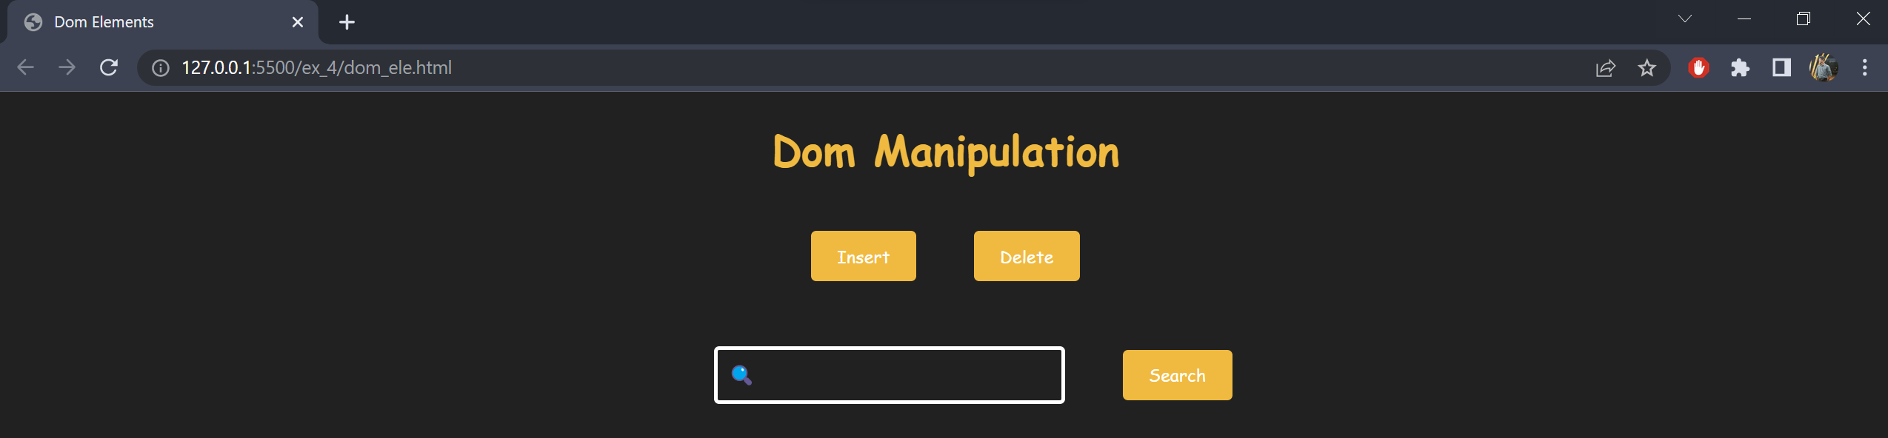

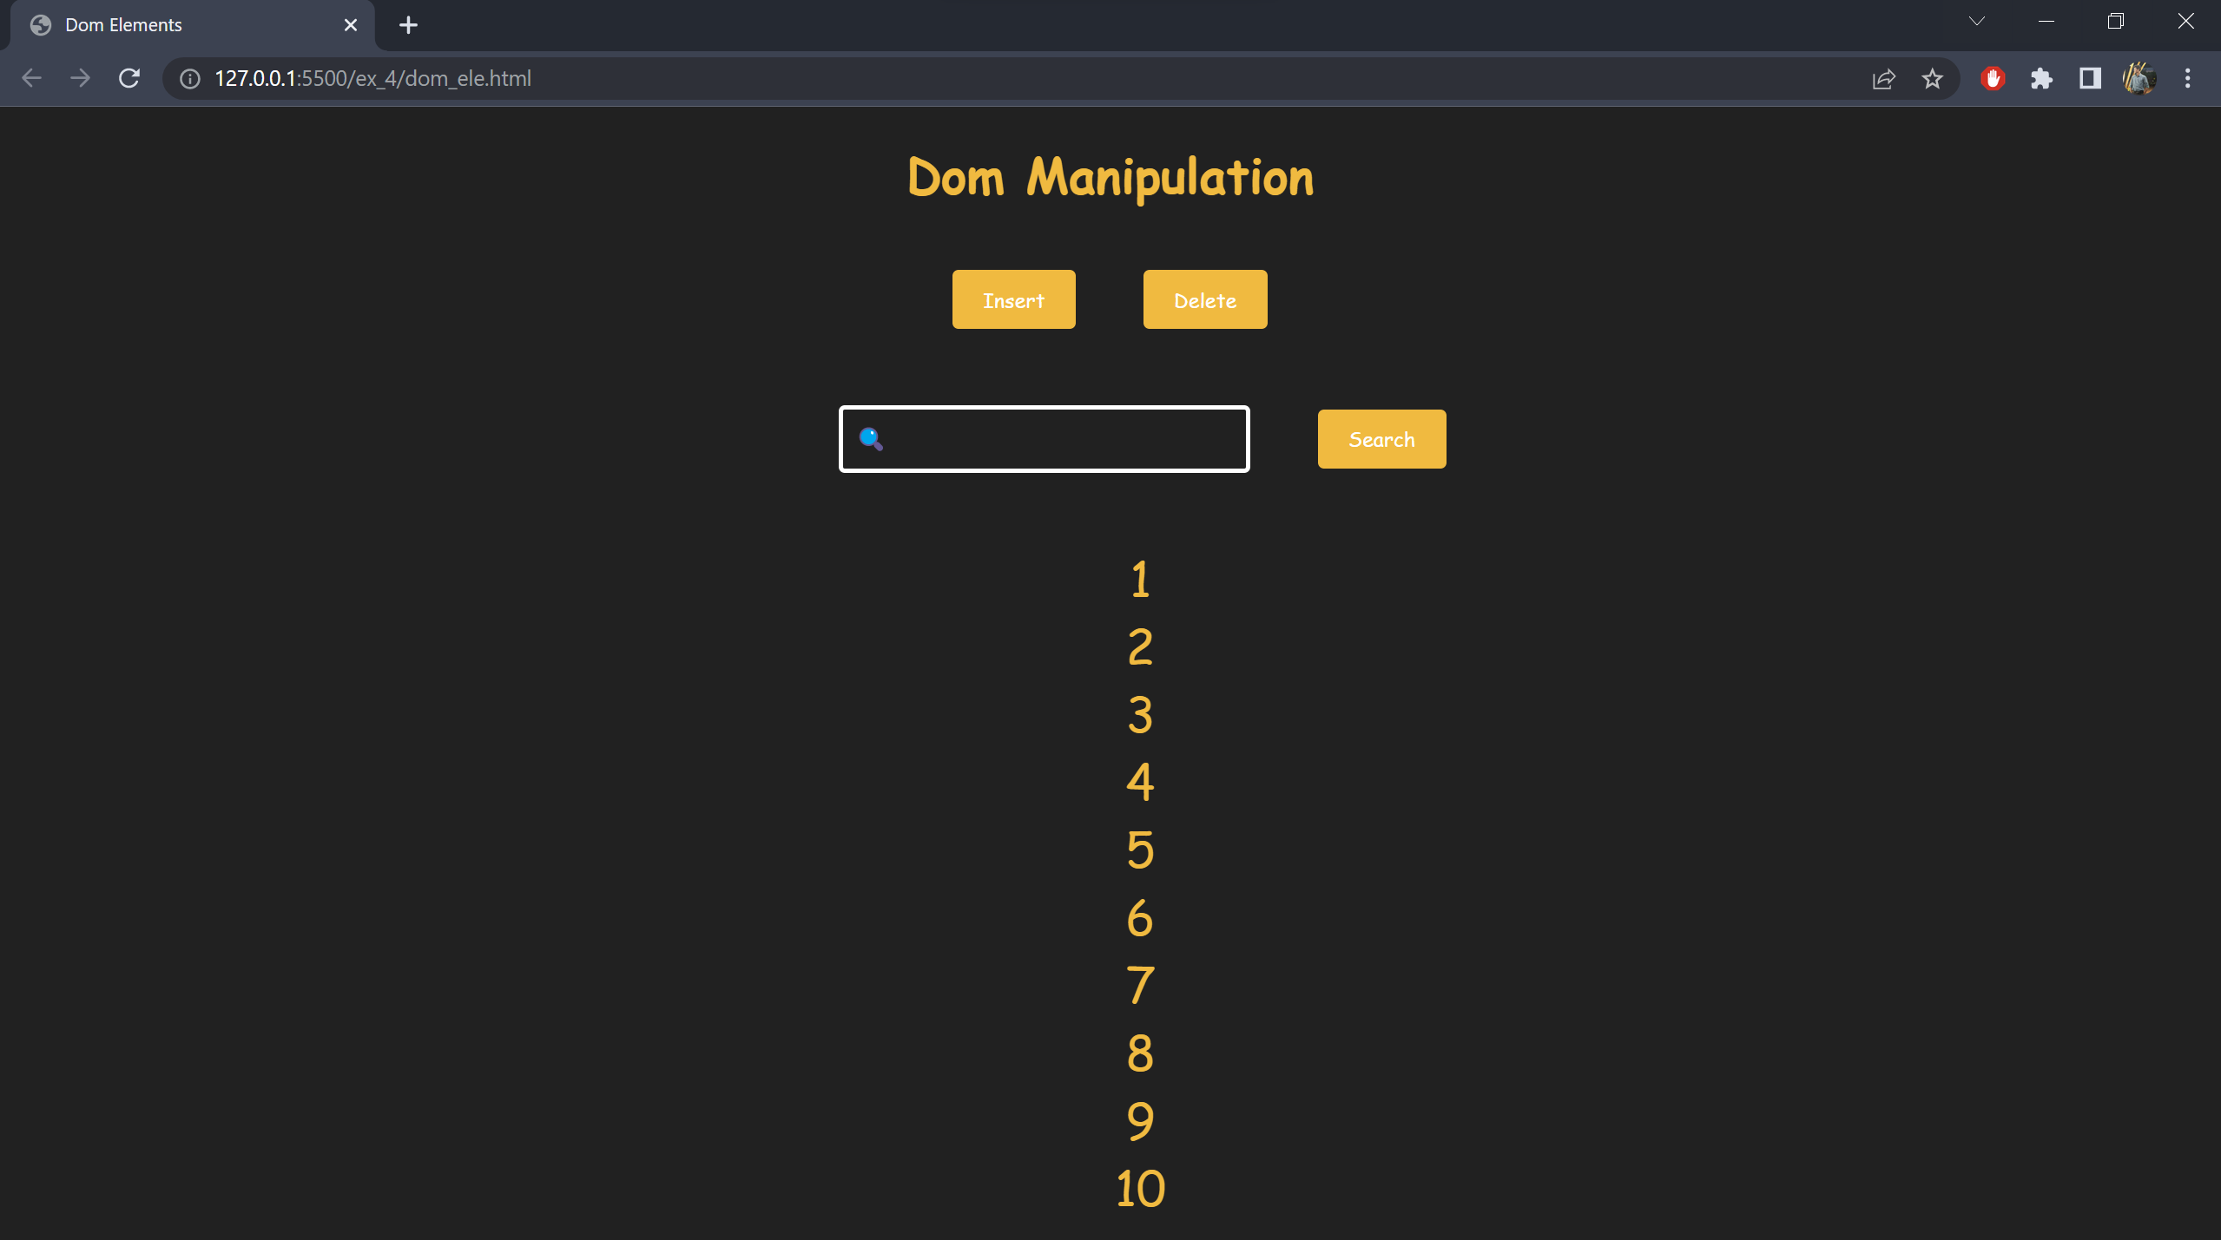

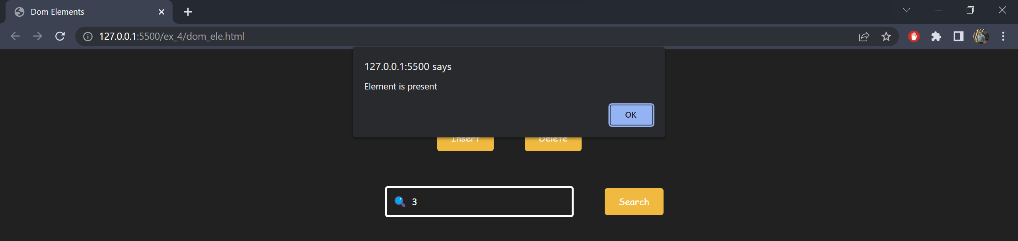

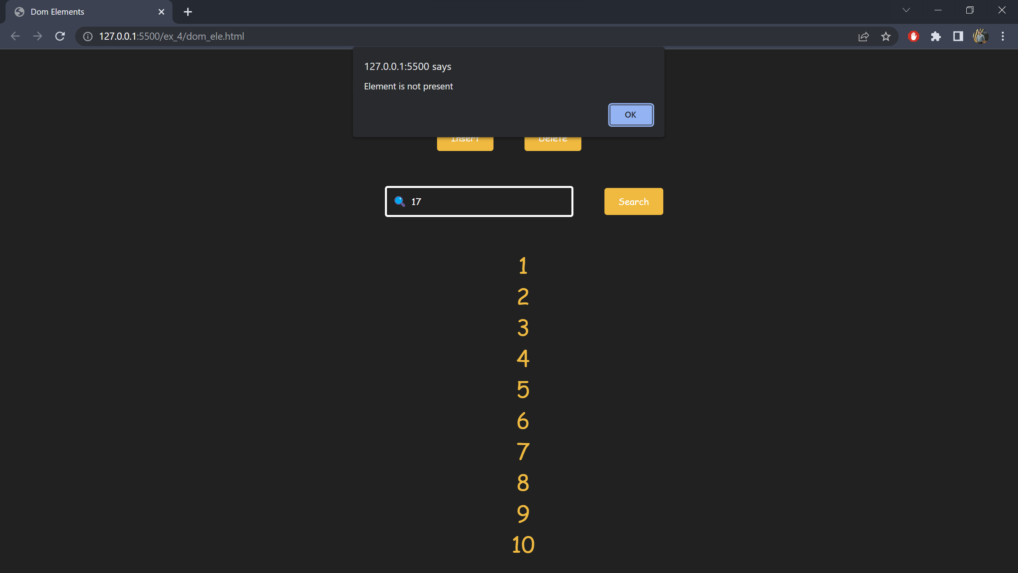

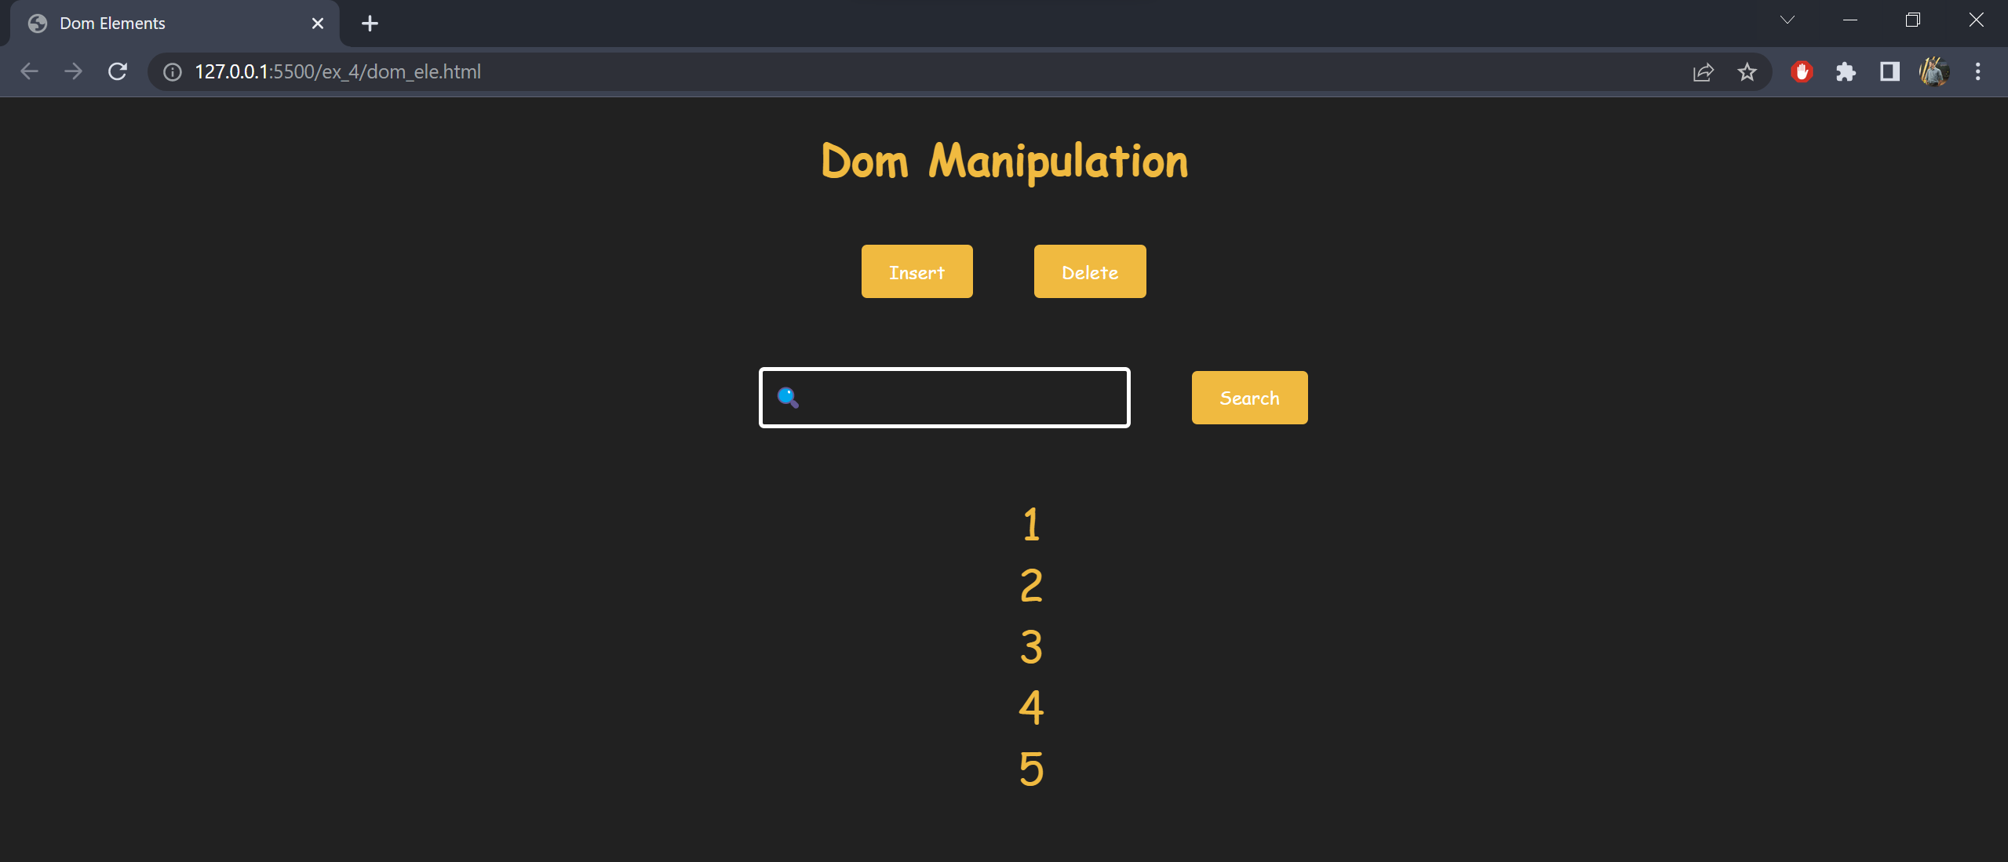

**Result:** Therefore the programs are coded successfully using javascript, regex and dom.

**Exercise 5 (a)**

**Date:** 12/04/2022

**Aim**

To implement a simple calculator using Angular JS.

**Code:**

<!DOCTYPE html>

<html lang="en">

<head>

<meta charset="UTF-8">

<meta http-equiv="X-UA-Compatible" content="IE=edge">

<meta name="viewport" content="width=device-width, initial-scale=1.0">

<title>Simple Calculator</title>

<script src="https://ajax.googleapis.com/ajax/libs/angularjs/1.8.2/angular.min.js"></script>

<style>

@import url('https://fonts.googleapis.com/css2?family=Montserrat:wght@100;400&display=swap');

* {

color: #212121;

font-family: 'Montserrat', sans-serif;

}

h1,

h2 {

font-weight: 900;

}

input {

width: 20%;

padding: 10px 16px;

margin: 10px 0px;

border: light solid #212121;

}

.result-box {

margin-top: 20px;

background-color: #FAB700;

width: 20%;

padding: 1px 16px 20px 16px;

line-height: 2em;

}

</style>

</head>

<body>

<div ng-app="">

<h1>Simple Calculator</h1>

<input type="number" ng-model="n1" placeholder="Enter the first number"><br />

<input type="number" ng-model="n2" placeholder="Enter the second number">

<div class="result-box" ng-show="n1 && n2">

<h2>Result</h2>

{{ n1 }} + {{ n2 }} = {{ n1+n2 }}<br />

{{ n1 }} - {{ n2 }} = {{ n1-n2 }}<br />

{{ n1 }} * {{ n2 }} = {{ n1*n2 }}<br />

{{ n1 }} / {{ n2 }} = {{ n1/n2 | number }}<br />

{{ n1 }} % {{ n2 }} = {{ n1%n2 }}<br />

</div>

</div>

</body>

</html>

**Output:**

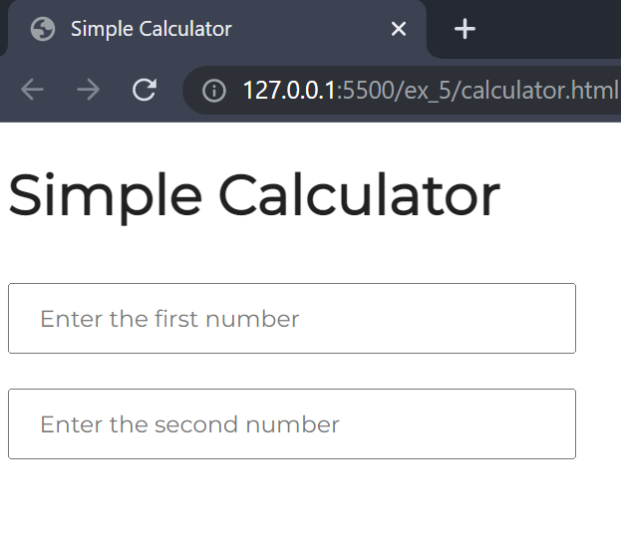

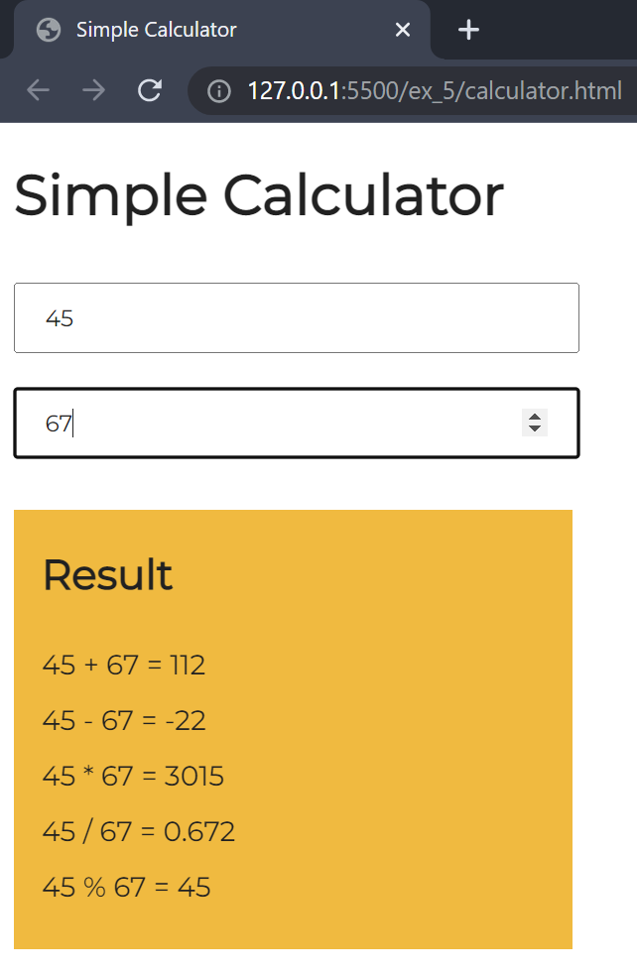

**Exercise 5 (b)**

**Date:** 12/04/2022

**Aim**

To implement components, services and controllers using Angular JS.

**Code:**

<!DOCTYPE html>

<html lang="en">

<head>

<meta charset="UTF-8">

<meta http-equiv="X-UA-Compatible" content="IE=edge">

<meta name="viewport" content="width=device-width, initial-scale=1.0">

<title>Services and Controllers</title>

<script src="https://ajax.googleapis.com/ajax/libs/angularjs/1.8.2/angular.min.js"></script>

</head>

<body>

<div ng-app="myApp" ng-controller="myCtrl">

<p>The hexadecimal value of 255 is:</p>

<h1>{{hex}}</h1>

</div>

<p>A custom service with a method that converts a given number into a hexadecimal number.</p>

<script>

var app = angular.module('myApp', []);

app.service('hexafy', function () {

this.myFunc = function (x) {

return x.toString(16);

}

});

app.controller('myCtrl', function ($scope, hexafy) {

$scope.hex = hexafy.myFunc(255);

});

</script>

</body>

</html>

**Output:**

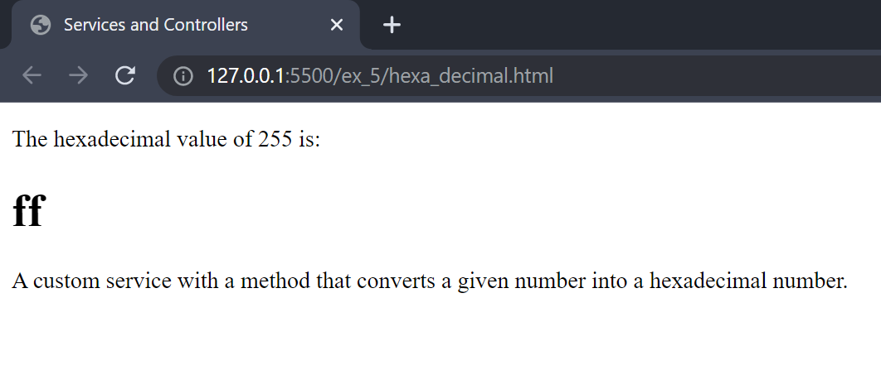

**Exercise 5 (c)**

**Date:** 12/04/2022

**Aim**

To implement search to filter items.

**Code:**

<!DOCTYPE html>

<html lang="en">

<head>

<meta charset="UTF-8">

<meta http-equiv="X-UA-Compatible" content="IE=edge">

<meta name="viewport" content="width=device-width, initial-scale=1.0">

<title>Filter and Search</title>

<script src="https://ajax.googleapis.com/ajax/libs/angularjs/1.8.2/angular.min.js"></script>

<style>

* {

font-family: 'Brush Script MT', cursive;

}

body {

color: #212121;

background-color: #FAB702;

text-align: center;

line-height: 3em;

}

input {

width: 30%;

margin: 20px;

padding: 10px;

background-color: #FAB702;

border: medium solid #212121;

border-radius: 8px;

}

li {

list-style: none;

}

</style>

</head>

<body ng-app="myApp">

<h1>Students List</h1>

<div ng-controller="myController">

<input type="text" ng-model="search" placeholder="search"><br />

<ul>

<li ng-repeat="student in studentsList | orderBy: 'name' | filter:search">{{ student.name }}</li>

</ul>

</div>

<script>

let myApp = angular.module("myApp", []);

myApp.controller("myController", function ($scope) {

$scope.studentsList = [

{ name: "Arman Cotton" },

{ name: "Shanay Johns" },

{ name: "Jayden Wheatley" },

{ name: "Amber Tucker" },

{ name: "Alia Beaumont" },

{ name: "Natan Daniels" },

{ name: "Chanice Barry" },

{ name: "Lucille Hanson" },

{ name: "Rhys Redmond" },

{ name: "Shelley Bolton" },

{ name: "Gregor Weston" },

{ name: "Jobe Mcmillan" },

{ name: "Roan Hahn" },

{ name: "Vickie Mcgregor" },

{ name: "Asiyah Lin" },

{ name: "Everett Dejesus" },

{ name: "Dotty Adam" },

{ name: "Aubree Dolan" },

{ name: "Komal Pittman" },

{ name: "Sanjay Mccann" }

]

});

</script>

</body>

</html>

**Output:**

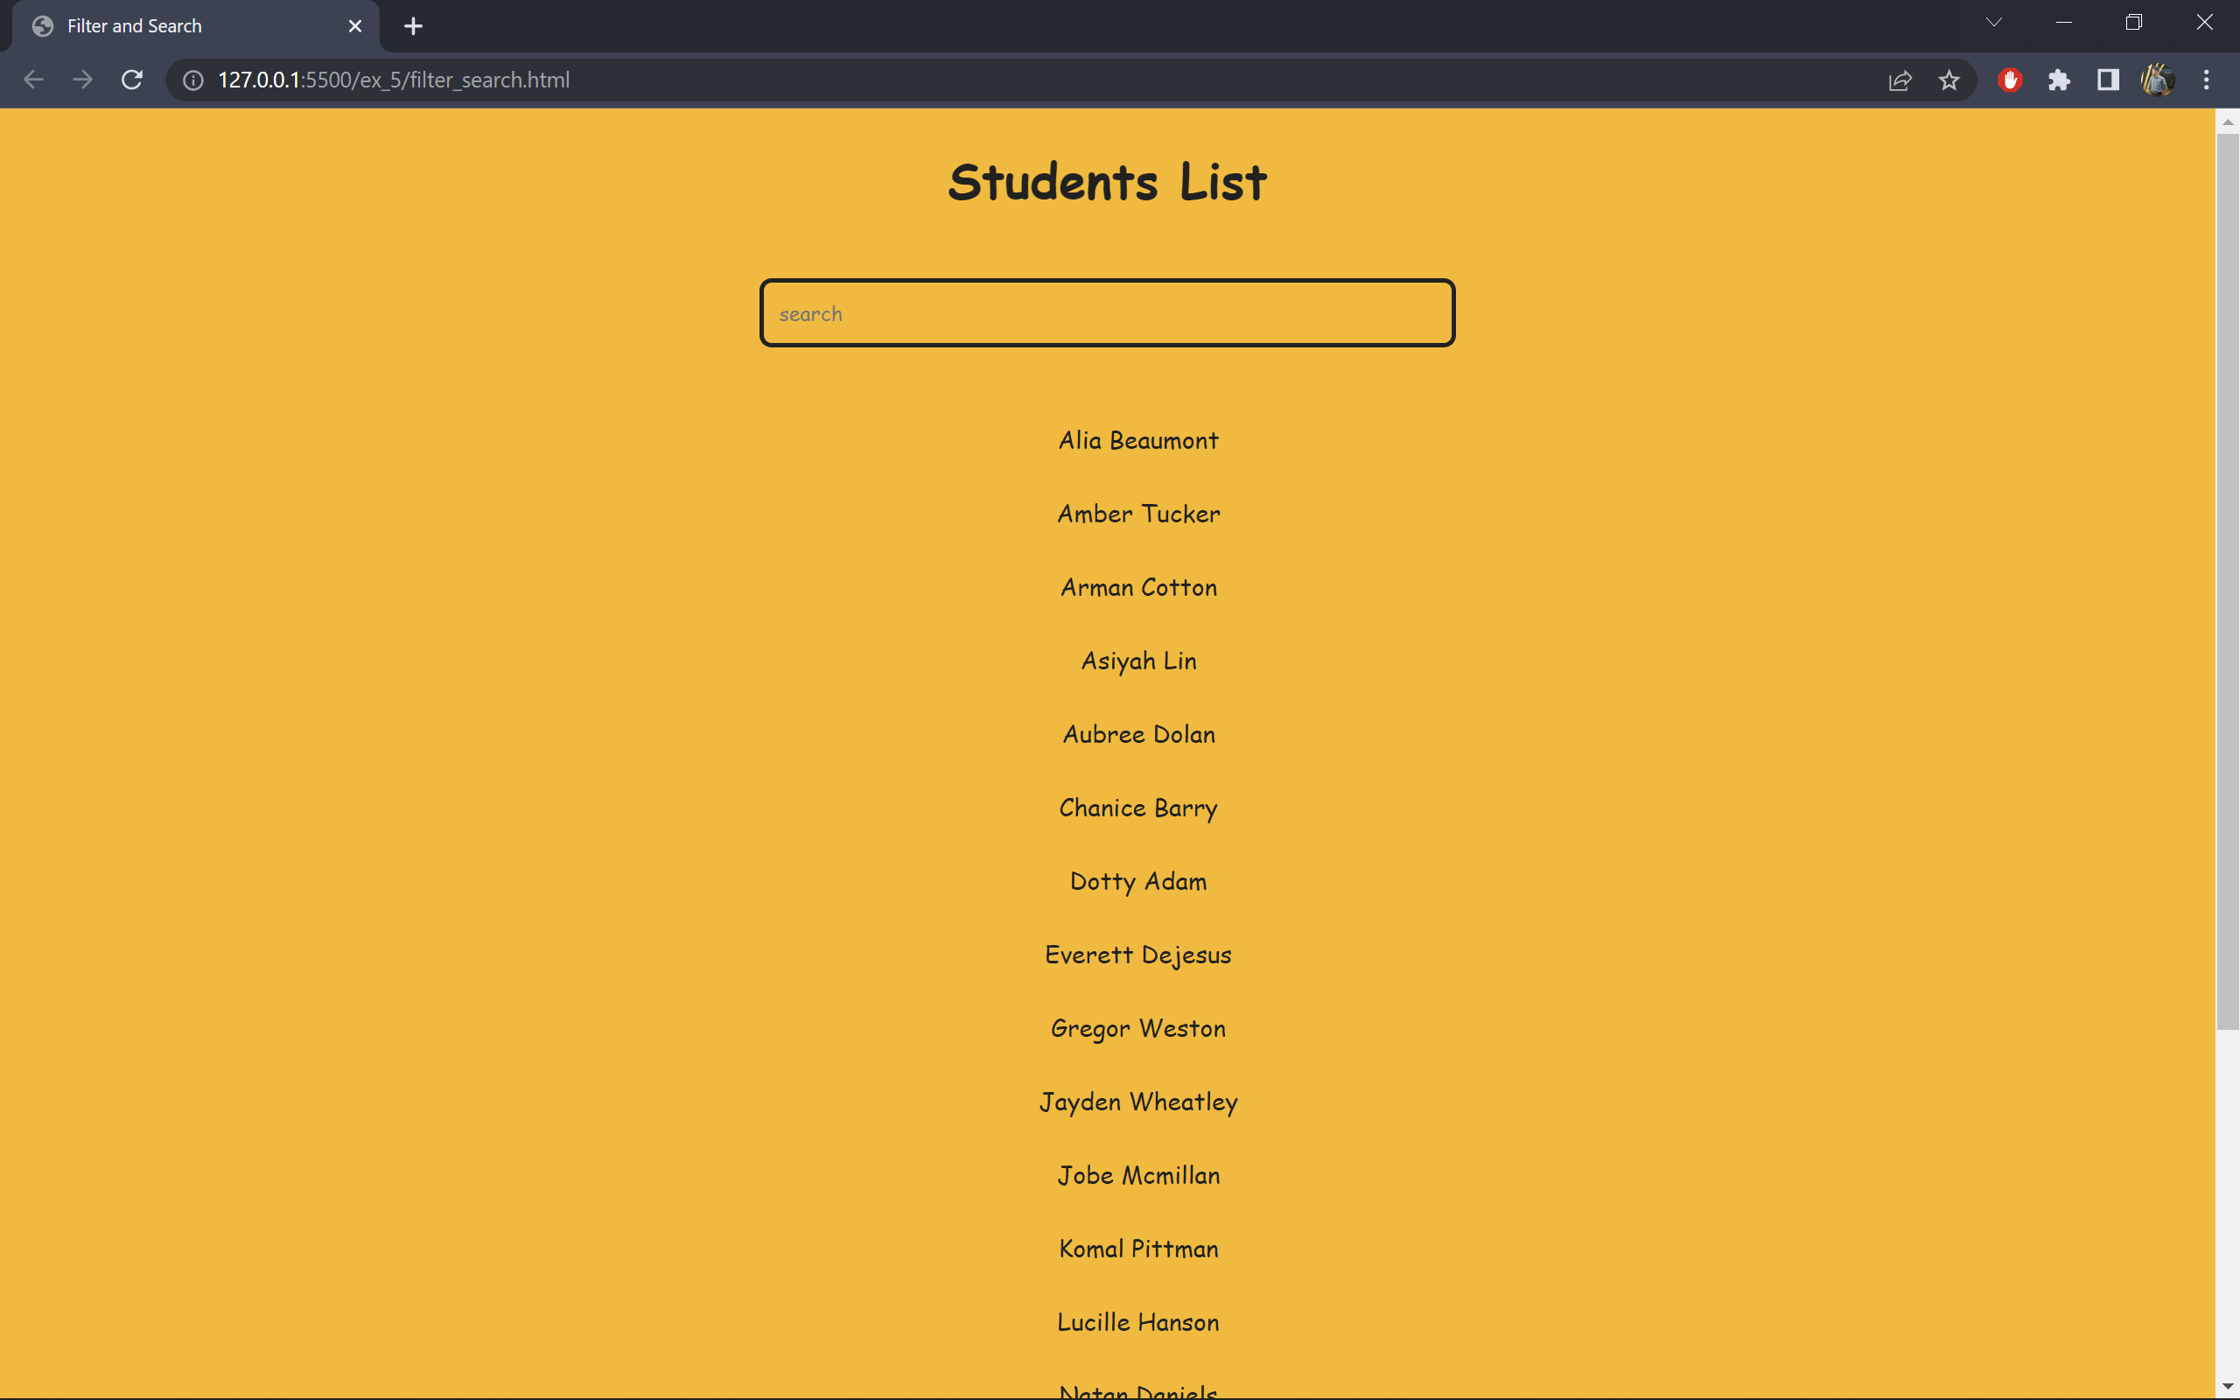

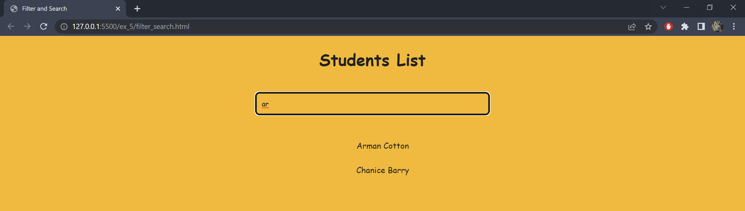

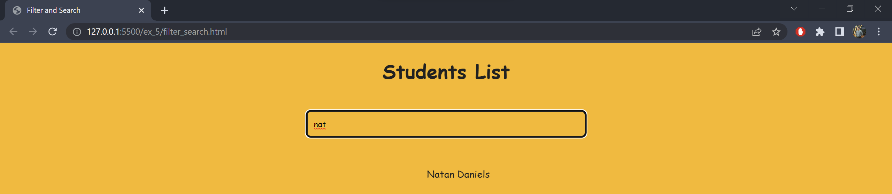

**Result:** The simple calculator, components, services, filters and controllers has been explored and implemented using angular js and their outputs were verified.

**Exercise 6**

**Date:** 19/04/2022

**Aim**

To design a webpage using angular-js switch and animations

**a) Angular Animations**

**Code:**

<!DOCTYPE html>

<html>

<head>

<title>Animations</title>

<style>

div {

transition: all linear 0.5s; background-color: lightskyblue; height: 100px;

}

.ng-hide {

background-color: black;

height: 0;

}

</style>

<script src="https://ajax.googleapis.com/ajax/libs/angularjs/1.6.9/angular.min.js"></script>

<script src="https://ajax.googleapis.com/ajax/libs/angularjs/1.6.9/angular-animate.js"></script>

</head>

<body ng-app="myApp">

<h1>Weather Forecast</h1>

<h2>Click for Bright sky <input type="checkbox" ng-model="myCheck"></h2>

<div ng-hide="myCheck"></div>

<script>

var app = angular.module('myApp', ['ngAnimate']);

</script>

</body>

</html>

**Output:**

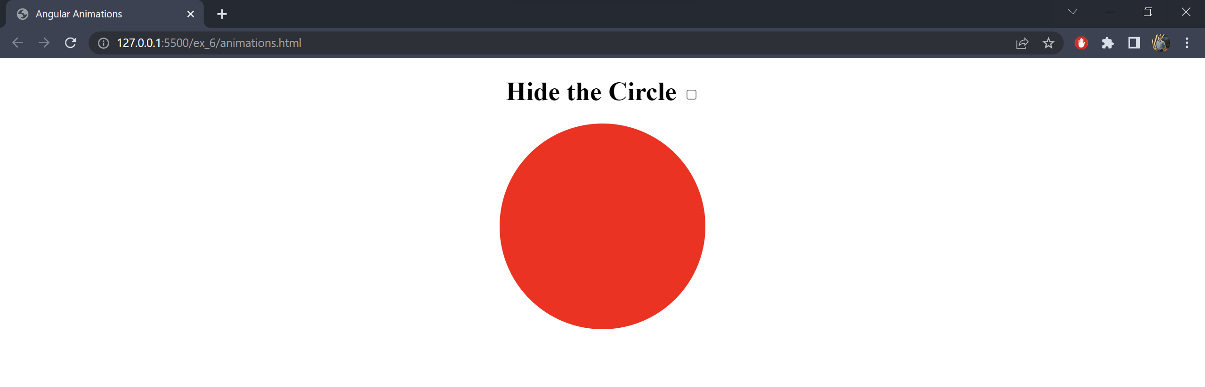

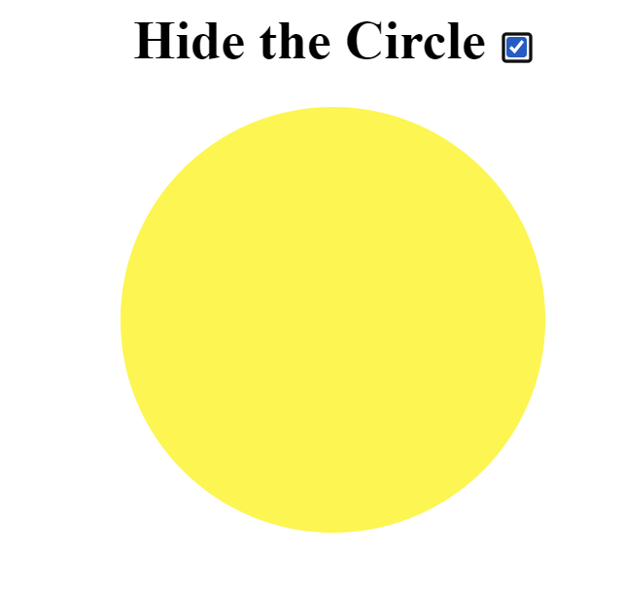

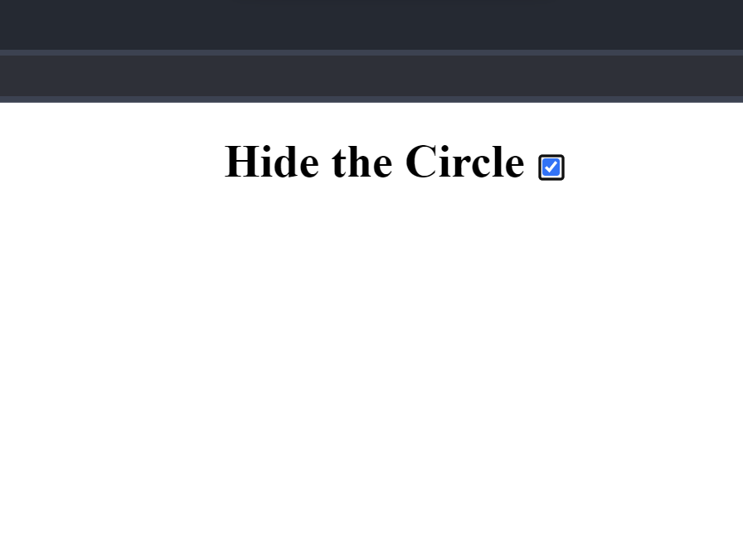

**b) Switching between Grid and List**

**Code:**

<!DOCTYPE html>

<html lang="en">

<head>

<meta charset="UTF-8">

<meta http-equiv="X-UA-Compatible" content="IE=edge">

<meta name="viewport" content="width=device-width, initial-scale=1.0">

<title>Angular Switch</title>

<style>

* {

box-sizing: border-box;

}

.column {

float: left;

width: 50%;

padding: 10px;

}

.row:after {

content: "";

display: table;

clear: both;

}

.btn {

border: none;

outline: none;

padding: 12px 16px;

background-color: #f1f1f1;

cursor: pointer;

}

.btn:hover {

background-color: #ddd;

}

.btn.active {

background-color: #666;

color: white;

}

</style>

</head>

<body>

<h2>List View or Grid View</h2>

<p>Click on a button to choose list view or grid view.</p>

<div id="btnContainer">

<button class="btn" onclick="listView()"><i class="fa fa-bars"></i> List</button>

<button class="btn active" onclick="gridView()"><i class="fa fa-th-large"></i> Grid</button>

</div>

<br>

<div class="row">

<div class="column" style="background-color:#aaa;">

<h2>Html </h2>

<p>The HyperText Markup Language or HTML is the standard markup language for documents designed to be

displayed in a web browser. </p>

</div>

<div class="column" style="background-color:#bbb;">

<h2>CSS</h2>

<p>Cascading Style Sheets is a style sheet language used for describing the presentation of a document

written in a markup language such as HTML.</p>

</div>

</div>

<div class="row">

<div class="column" style="background-color:#ccc;">

<h2>JS</h2>

<p>JavaScript, often abbreviated JS, is a programming language that is one of the core technologies of the

World Wide Web, alongside HTML and CSS.</p>

</div>

<div class="column" style="background-color:#ddd;">

<h2>Angular Js</h2>

<p>AngularJS was a JavaScript-based open-source front-end web framework for developing single- page

applications.</p>

</div>

</div>

<script>

// Get the elements with class="column"

var elements = document.getElementsByClassName("column");

//Declare loop variable

var i;

// List View

function listView() {

for (i = 0; i < elements.length; i++) {

elements[i].style.width = "100%";

}

}

// Grid View

function gridView() {

for (i = 0; i < elements.length; i++) {

elements[i].style.width = "50%";

}

}

</script>

</body>

</html>

**Output:**

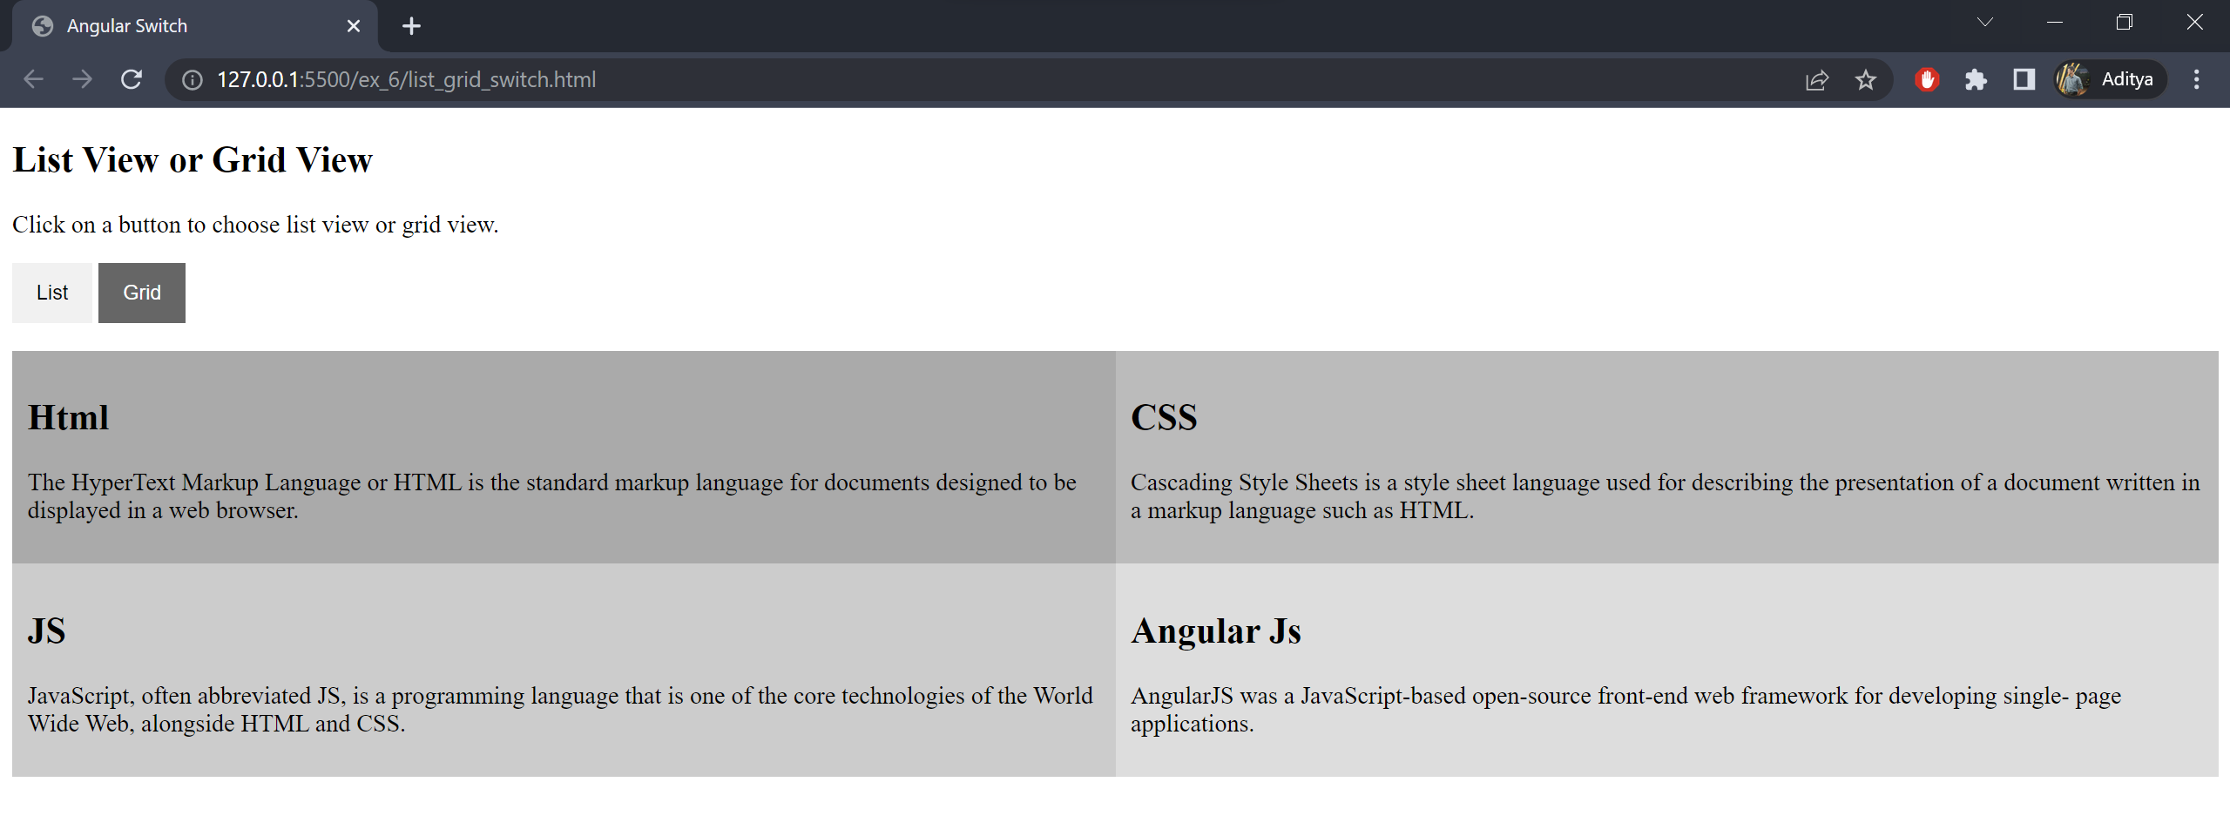

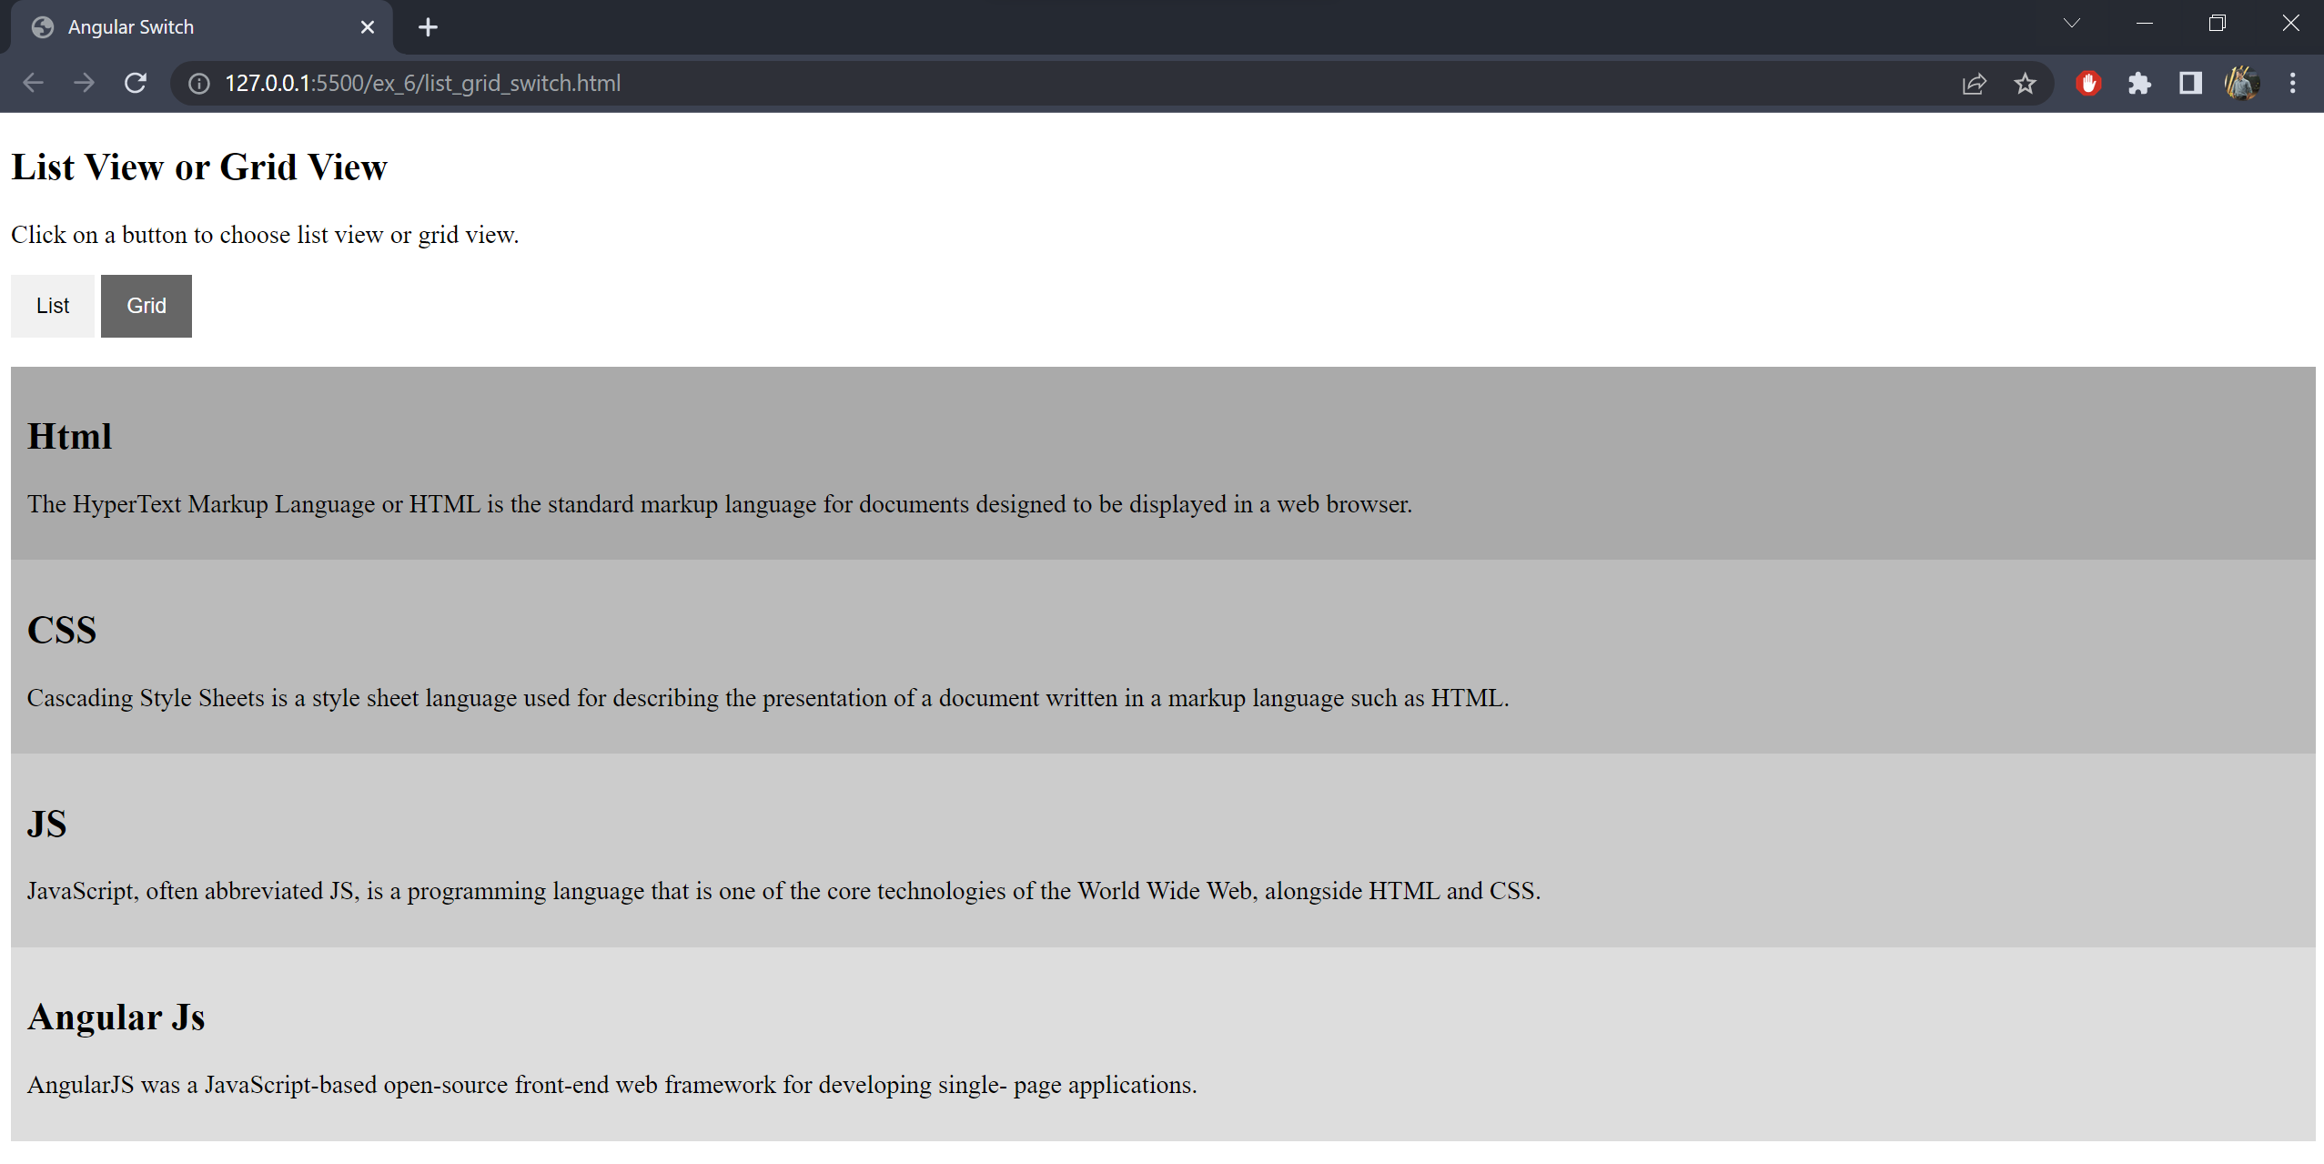

**Result:** The Angular JS animations and switch has been explored and implemented in html and their outputs were verified.

**Exercise 7**

**Date:** 26/04/2022

**Aim**

To write an angular program to create form with real time updating.

**Algorithm:**

1. Import angular script
2. Create the form using the <form> tag and add labels and inputs to the same.
3. Set appropriate input types for all parameters.
4. Write an angular function to set patterns or Regular expressions as constraints foreach input as required.
5. Install PHP and MySQL database.
6. Create the required database on MySQL with the appropriate database name,username, password, and table.
7. Connect the form to the PHP file using the form action tag (refer the last page for code).
8. Validate the form by calling the angular function after submitting the form usingthe ng-controller tag.
9. Create a display file, to show all the inputs received into the database, in a table like manner.
10. Send alerts if there is an error and after successful submission.
11. Display the real-time entries received in the table.

**Code:**

**Index.html**

<!DOCTYPE html>

<html>

<head>

<title></title>

<script src="angular.js"></script>

<script src="angular-route.js"></script>

<script src="script.js"></script>

<script src="https://code.angularjs.org/1.8.2/angular.min.js"></script>

</head>

<body style="text-align: center;" ng-app="myApp" ng-controller="myController">

<h2>Weight Lifting Tracker</h2>

<p>Track your progress!</p>

<hr>

<form action="makedb.php" method="post">

<p>Select type of Weight Lift:

<select name="lift">

<option value="bench_press">Bench Press</option>

<option value="squats">Squats</option>

<option value="pull_ups">Pull ups</option>

</select>

</p>

<p>Weight (in Kg): <input type="number" name="wt" id="wt" ng-model="wt" required></p>

<p>Date: <input type="date" name="ldate" id="ldate" ng-model="ldate" required></p>

<input type="submit" value="Track!">

</form>

</body>

</html>

**Script.js**

var app = angular.module("myApp",[]);

app.controller("myController", function ($scope){

$scope.msg ="Hi";

});

Makedb.php

<?php

$host = 'localhost';

$user = 'root';

$pswd = '';

$db = 'test';

$conn = mysqli_connect($host, $user, $pswd, $db);

if(!$conn){

die('Could not connect to database'.mysqli_connect_error());

}

else{

echo 'Connected to db successfully';

}

$sql = "CREATE TABLE wtrecs(ldate INT, lift VARCHAR(80), wt INT, PRIMARY KEY(ldate))";

if(mysqli_query($conn, $sql)){

echo '<h1>table created to record weights</h1>';

}

else{

echo "<h1>table to record weights couldn't be created!</h1>";

}

$ldate = $_POST["ldate"];

$lift = $_POST["lift"];

$wt = $_POST["wt"];

$sql1 = "INSERT INTO wtrecs(ldate, lift, wt) VALUES('$ldate', '$lift', '$wt')";

$rs = mysqli_query($conn, $sql1);

if($rs){

echo '<h1>Record added</h1>';

}

// Table making

$sql3 = "SELECT * FROM wtrecs";

$rs1 = mysqli_query($conn, $sql3);

echo '<br>';

echo '<table border="1">';

while($row = mysqli_fetch_assoc($rs1)){

echo '<tr>';

foreach($row as $value){

echo "<td>" . $value . "</td>";

}

echo '</tr>';

}

echo '</table>';

?>

**Output:**

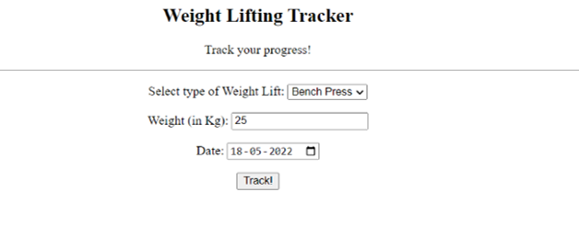

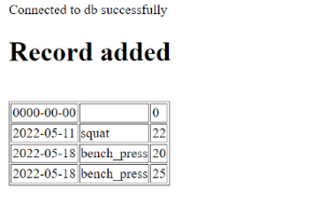

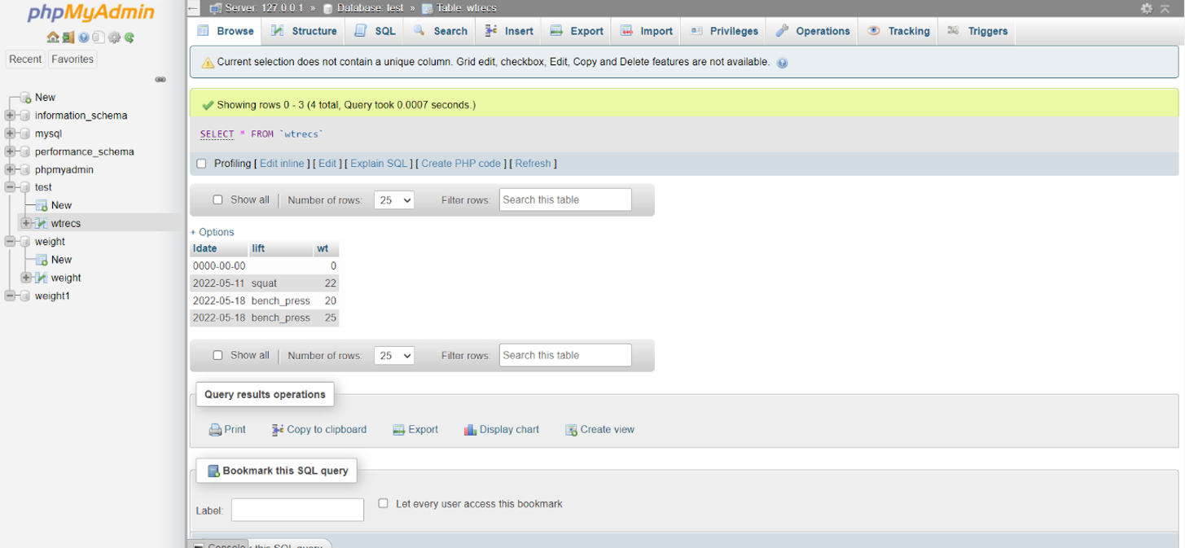

**Result:** The real-time form with PHP has been designed and working properly and their outputs were verified.

**Exercise 8**

**Date:** 10/05/2022

**Aim**

To design a navigation menu for the website using Angular JS.

**Algorithm:**

1. Import angular script.

2. Create a several webpages like HOME, CONTACT, ABOUT in Html.

3. Link those websites created using link tag in the nav bar properly.

4. Use NgRoute in angular for the routing between these webpages.

5. Connect every page to the homepage.

6. Add appropriate CSS for the look.

**Code:**

<!DOCTYPE html>

<html lang="en">

<head>

<meta charset="UTF-8">

<meta http-equiv="X-UA-Compatible" content="IE=edge">

<meta name="viewport" content="width=device-width, initial-scale=1.0">

<title>Nav Menu</title>

<script src="https://ajax.googleapis.com/ajax/libs/angularjs/1.8.2/angular.min.js"></script>

<style>

* {

margin: 0;

padding: 0;

}

body {

font: 15px/1.3 'Open Sans', sans-serif;

color: #5e5b64;

text-align: center;

}

a,

a:visited {

outline: none;

color: #389dc1;

}

a:hover {

text-decoration: none;

}

section,

footer,

header,

aside,

nav {

display: block;

}

nav {

display: inline-block;

margin: 60px auto 45px;

background-color: #55B460;

box-shadow: 0 1px 1px #ccc;

border-radius: 2px;

}

nav a {

display: inline-block;

padding: 18px 30px;

color: #fff !important;

font-weight: bold;

font-size: 16px;

text-decoration: none !important;

line-height: 1;

text-transform: uppercase;

background-color: transparent;

-webkit-transition: background-color 0.25s;

-moz-transition: background-color 0.25s;

transition: background-color 0.25s;

}

nav a:first-child {

border-radius: 2px 0 0 2px;

}

nav a:last-child {

border-radius: 0 2px 2px 0;

}

nav.home .home,

nav.team.team,

nav.about .about,

nav.contact .contact {

background-color: #5867E3;

}

p {

font-s color: #7d9098;

}

p b {

color: #ffffff;

display: inline-block;

padding: 5px 10px;

background-color: #DC64C6;

border-radius: 2px;

size: 22px;

font-weight: bold;

text-transform: uppercase;

font-size: 18px;

}

</style>

</head>

<body ng-app>

<nav class="{{active}}" ng-click="$event.preventDefault()">

<a href="#" class="home" ng-click="active='home'">Home</a>

<a href="#" class="about" ng-click="active='about'">About</a>

<a href="#" class="contact" ng-click="active='contact'">Contact</a>

</nav>

<p ng-show="active">You chose <b>{{active}}</b></p>

</body>

</html>

**Output:**

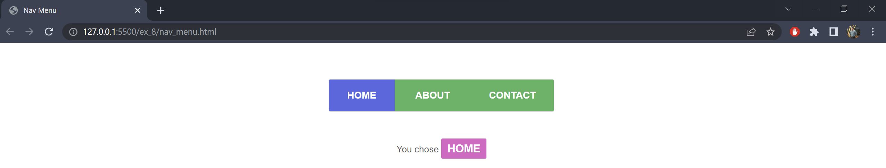

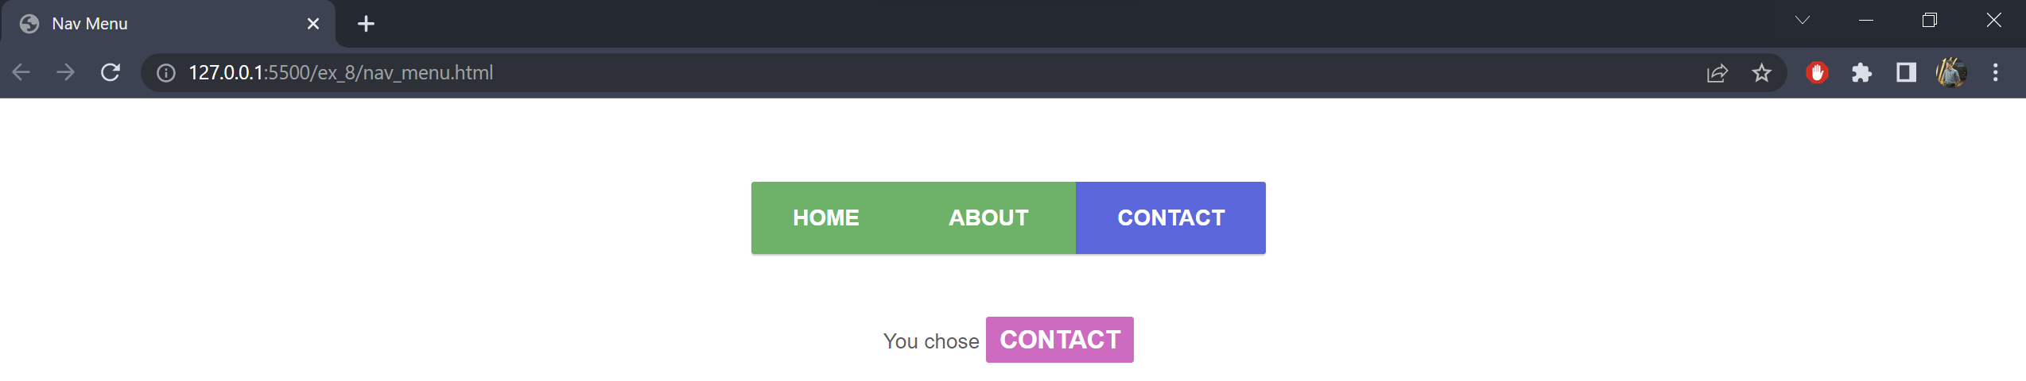

**Result:** The navigation menu using angular has been done properly and their outputs were verified.

**Exercise 9**

**Date:** 17/05/2022

**Aim**

To make a dynamic website using node js and express

**Code:**

var express = require('express')

var app = express();

app.get("/", (req, res) => res.send("Welcome to the home page"));

app.get("/about", (req, res) => res.send("Welcome to the about page"));

app.get("/name/:name", (req, res) => res.send("Your name is: " + req.params.name));

app.listen(3000, function (err) {

if (err) console.log(err);

console.log("Server has Started in http://localhost:3000/");

});

**Output:**

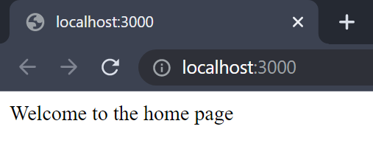

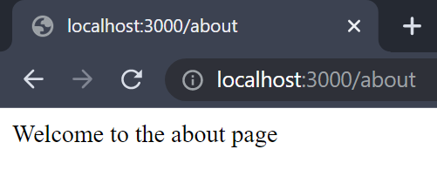

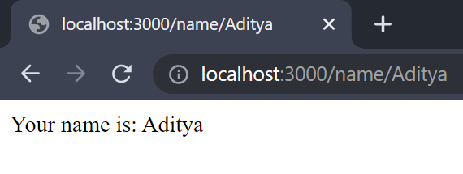

**Result:** The website using node.js and express has been implemented and executed successfully.

**Exercise 10**

**Date:** 31/05/2022

**Aim**

To create a simple web application using the MEAN stack

**Code:**

**CredCard.html**

<!DOCTYPE html>

<html>

<head>

<title>Payment Gateway</title>

<meta charset="UTF-8">

<meta name="description" content="Payment Gateway">

<meta name="author" content="Aditya R">

<style>

body {

background-color: beige;

font-family: Arial, Helvetica, sans-serif;

font-size: large;

align-items: center;

text-align: center;

}

#block1 {

background-color: darkgray;

vertical-align: middle;

text-align: left;

width: 700px;

border: 15px #3a0d0d;

padding: 20px;

margin: 10px;

}

#block2 {

padding: 5px 100px;

}

</style>

</head>

<body>

<script src="https://ajax.googleapis.com/ajax/libs/angularjs/1.6.9/angular.min.js"></script>

<div id="block1">

<h3 style="background-color:black;color: floralwhite;text-align:

center; ">Payment Details</h3><br>

<div id="block2" ng-app="">

<p>Please enter your details {{name}}!!</p>

<form id="payment" onsubmit="return validateForm()" method="post" action="http://localhost:3000/submit">

<label for="name">Name:</label><input type="text" id="name" ng-model="name" name="name"><br>

<div class="boxes">

<label for="cardno1">Card Number:</label>

<input type="text" id="cardno1" name="cardno1" ng-model="cardno1" tabindex="1" class="card1"

maxlength="4" size="4" onkeyup="move(this,this.value)">

<input type="text" id="cardno2" name="cardno2" ng-model="cardno2" tabindex="2" class="card2"

maxlength="4" size="4" onkeyup="move(this,this.value)">

<input type="text" id="cardno3" name="cardno3" ng-model="cardno3" tabindex="3" class="card3"

maxlength="4" size="4" onkeyup="move(this,this.value)">

<input type="text" id="cardno4" name="cardno4" ng-model="cardno4" tabindex="4" class="card4"

maxlength="4" size="4" onkeyup="move(this,this.value)">

<br>

</div>

<div class="form-group" id="exp-date">

<label for="expdate">Expiry Date:</label>

<select class="month" name="month_id" id="month_id" ng-model="month_id">

</select>

<select class="year" name="year_id" id="year_id" ng-model="year_id">

<option value="2021"> 2021</option>

</select>

</div>

<label for="cvv">CVV/CVC:</label>

<input type="tel" name="cvv" id="cvv" ng-model="cvv" maxlength="3" size="3">

<br><br>

<img src="logos2.jpg" align="center" usemap="#workmap" width="180" height="60"><br><br>

<input type="submit" value="Submit" style="position:

relative">

</form>

</div>

</div>

<form method="post" action="http://localhost:3000/delete">

<label for="delname">Enter Name to delete:</label>

<input type="text" id="delname" ng-model="delname" name="delname"><br>

<input type="submit" value="Delete">

</form>

<br>

<form method="post" action="http://localhost:3000/update">

<label for="oldname">Old Name:</label>

<input type="text" id="oldname" ng-model="oldname" name="oldname"><br>

<label for="newname">New Name:</label>

<input type="text" id="newname" ng-model="newname" name="newname"><br>

<input type="submit" value="Update">

</form>

<br>

<form method="get" action="http://localhost:3000/all">

<input type="submit" value="View all Transactions">

</form>

</body>

<script>

//Using DOM to add months and years

var yr = 2021;

var year = document.getElementById("year_id");

var month = document.querySelector(".month");

for (let i = 1; i <= 12; i++) {

let doc = document.createElement("option");

doc.text = i;

month.add(doc);

}

for (let i = 1; i <= 5; i++) {

let doc = document.createElement("option");

doc.text = yr + i;

year.add(doc);

}

function validateForm() {

var cardno1 = document.forms["payment"]["cardno1"].value;

var cardno2 = document.forms["payment"]["cardno2"].value;

var cardno3 = document.forms["payment"]["cardno3"].value;

var cardno4 = document.forms["payment"]["cardno4"].value;

var cardno = cardno1 + cardno2 + cardno3 + cardno4;

var uname = document.forms["payment"]["name"].value;

var cvv = document.forms["payment"]["cvv"].value;

var yr_chosen = document.forms["payment"]["year_id"].value;

var flag = 1;

if (uname == "" || cardno == "" || cvv == "") {

window.alert("None of the fields can be empty!!"); return

false;

}

else {

//var cardno_test = new RegExp("^\\d{16}");

var cvv_test = new RegExp("^\\d{3}");

var name_test = new RegExp("^[a-zA-Z. ]*$");

var masterCard = new

RegExp("^(5[1-5][0-9]{14}|2(22[1-9][0-9]{12}|2[3-9][0-9]{13}|[3-6][0-9]{14

}| 7[0 - 1][0 - 9]{ 13 }| 720[0 - 9]{ 12 }))$");

var visa = new RegExp("^4[0-9]{12}(?:[0-9]{3})?$");

var rupay = new RegExp("^6[0-9]{15}$");

if (!name_test.test(uname)) {

alert("Invalid Name Field"); flag = 0;

}

if (!masterCard.test(cardno) && !visa.test(cardno) &&

!rupay.test(cardno)) {

window.alert("Invalid Card No.");

flag = 0;

}

if (!cvv_test.test(cvv)) {

alert("Invalid CVV"); flag = 0;

}

//alert(yr_chosen);

if (yr_chosen == "2021") {

var d = new Date();

var n = d.getMonth(); n++;

var mon_chosen =

document.forms["payment"]["month_id"].value;

if (mon_chosen < n) {

alert("Invalid Expiry Date"); flag = 0;

}

}

if (flag == 1) {

alert("Successful Submission!!");

return true;

}

return false;

}

}

function move(x, y) {

if (y.length == x.maxLength) {

let next = x.tabIndex;

if (next == 1) {

var cardno1 = document.forms["payment"]["cardno1"].value;

var rupay_4 = new RegExp("^6[0-9]{3}$");

var visa_4 = new RegExp("^4[0-9]{3}$");

var master_4 = new RegExp("^5[1-5][0-9]{2}");

if (!visa_4.test(cardno1) && !rupay_4.test(cardno1) &&

!master_4.test(cardno1)) {

window.alert("Invalid Card No.!!");

}

else {

console.log(document.querySelector(".boxes").childElementCount);

if (next < document.querySelector(".boxes").childElementCount) {

document.querySelector(".card" +

(next + 1)).focus();

}

}

}

else {

console.log(document.querySelector(".boxes").childElementCount);

if (next < document.querySelector(".boxes").childElementCount) {

document.querySelector(".card" + (next + 1)).focus();

}

}

}

}

</script>

</html>

**Cred.js**

var express = require('express');

var path = require('path');

var bodyParser = require('body-parser');

var mongodb = require('mongodb');

var dbConn = mongodb.MongoClient.connect('mongodb://localhost:27017', {

useNewUrlParser: true,

useUnifiedTopology: true

});

var app = express();

app.use(bodyParser.urlencoded({ extended: false }));

app.use(express.static(path.resolve(__dirname, 'public')));

app.set('view engine', 'pug');

app.post('/submit', function (req, res) {

var data = req.body;

var cardno = data.cardno1 + data.cardno2 + data.cardno3 + data.cardno4;

var record =

{

"Name": data.name, "CardNo": cardno, "Month": data.month_id, "Year": data.year_i

d, "CVV": data.cvv

}

dbConn.then(function (db) {

var dbo = db.db("webprog");

//delete req.body._id; // for safety reasons

dbo.collection('creditcard').insertOne(record);

});

res.send('Data received:\n' + JSON.stringify(record));

});

app.get('/all', function (req, res) {

dbConn.then(function (db) {

var dbo = db.db("webprog");

dbo.collection("creditcard").find({},

{ "Name": 1, "CardNo": 0, "Month": 0, "Year": 0, "CVV": 0 }).toArray(function (err,

result) {

if (err) throw err;

console.log(result);

//res.send('All records:\n\n' + JSON.stringify(result));

res.render('allpug', { result: result });

});

//var reco=dbo.collection('creditcard').find({});

//console.log(reco);

});

}); app.post('/delete', function (req, res) {

dbConn.then(function (db) {

var dbo = db.db("webprog");

var data = req.body.delname;

var myquery = { Name: data };

dbo.collection("creditcard").deleteMany(myquery, function (err,

obj) {

if (err) throw err;

console.log(obj.result.n + " document(s) deleted");

res.send(obj.result.n + " document(s) deleted");

//db.close();

});

});

});

app.post('/update', function (req, res) {

dbConn.then(function (db) {

var dbo = db.db("webprog");

var myquery = { Name: req.body.oldname };

var newvalues = { $set: { Name: req.body.newname } };

dbo.collection("creditcard").updateOne(myquery, newvalues,

function (err, obj) {

if (err) throw err;

else {

console.log("1 document updated");

res.send("1 document updated");

}

});

});

});

app.listen(3000, function (err) {

if (err) console.log(err);

console.log("Server listening on PORT", 3000);

});

**All.pug**

html

body

table(style='text-align:center;width:50%', border='1')

tr

th Name

th CardNo

th Month

th Year

th CVV

each item,i in result

tr

td= item.Name

td= item.CardNo

td= item.Month

td= item.Year

td= item.CVV

**Output:**

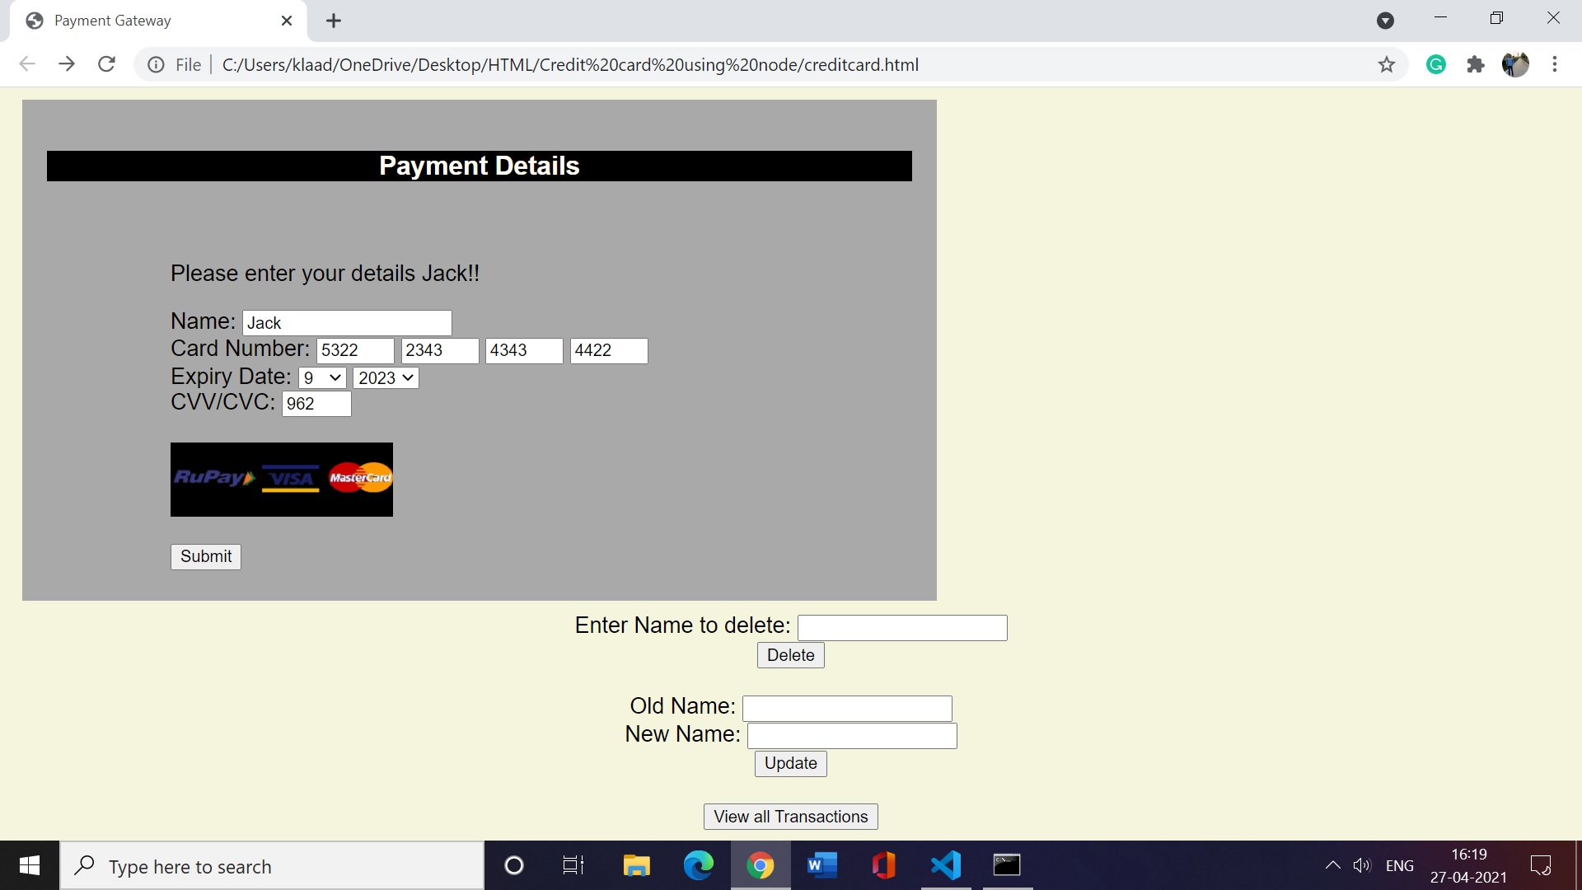







**Result:** A simple web application has been created and executed successfully using the MEAN stack.

**Exercise 11**

**Date:** 07/06/2022

**Aim**

To create a chat application using multiple rooms using node and express

**Code:**

**index.html**

<!DOCTYPE html>

<html lang="en">

<head>

<meta charset="UTF-8">

<meta http-equiv="X-UA-Compatible" content="IE=edge">

<meta name="viewport" content="width=device-width, initial-scale=1.0">

<title>Chatroom</title>

<style>

#bordering {

border: 25px solid transparent;

padding: 30px;

border-image: url(border.jpg) 60 round;

background-color: PeachPuff;

}

div {

text-align: center;

}

</style>

<script src="/socket.io/socket.io.js"></script>

<script src="https://ajax.googleapis.com/ajax/libs/jquery/1.6.4/jquery.min.js"></script>

<script>

var socket = io.connect('http://localhost:8080');

socket.on('connect', function () {

socket.emit('adduser', prompt("What's your name?"));

});

socket.on('updatechat', function (username, data) {

$('#conversation').append('<b>' + username + ':</b> ' + data + '<br>');

});

socket.on('updaterooms', function (rooms, current_room) {

$('#rooms').empty();

$.each(rooms, function (key, value) {

if (value == current_room) {

$('#rooms').append('<div>' + value + '</div>');

}

else {

$('#rooms').append('<div><a href="#" onclick="switchRoom(\'' + value + '\')">' + value + '</a></div>');

}

});

});

function switchRoom(room) {

socket.emit('switchRoom', room);

}

$(function () {

$('#datasend').click(function () {

var message = $('#data').val();

$('#data').val('');

socket.emit('sendchat', message);

});

$('#data').keypress(function (e) {

if (e.which == 13) {

$(this).blur();

$('#datasend').focus().click();

}

});

});

</script>

</head>

<body>

<div id="bordering">

<b>ROOMS</b>

<div id="rooms"></div>

<div id="conversation"></div>

<input id="data" style="width:200px;" />

<input type="button" id="datasend" value="send" />

</div>

</body>

</html>

**App.js**

const express = require('express');

const app = express();

const http = require('http').Server(app);

const io = require('socket.io')(http);

app.use(express.static(__dirname + '/public'));

app.get('/', function (req, res) {

res.sendFile(__dirname + '/index.html');

});

var usernames = {};

var rooms = ['room1', 'room2', 'room3'];

io.sockets.on('connection', function (socket) {

socket.on('adduser', function (username) {

socket.username = username;

socket.room = 'room1';

usernames[username] = username;

socket.join('room1');

socket.emit('updatechat', 'SERVER', 'you have connected to room1');

socket.broadcast.to('room1').emit('updatechat', 'SERVER', username + 'has connected to this room');

socket.emit('updaterooms', rooms, 'room1');

});

socket.on('sendchat', function (data) {

io.sockets.in(socket.room).emit('updatechat', socket.username, data);

});

socket.on('switchRoom', function (newroom) {

socket.leave(socket.room);

socket.join(newroom);

socket.emit('updatechat', 'SERVER', 'you have connected to ' + newroom);

socket.broadcast.to(socket.room).emit('updatechat', 'SERVER', socket.username + ' has left this room');

socket.room = newroom;

socket.broadcast.to(newroom).emit('updatechat', 'SERVER', socket.username + ' has joined this room');

socket.emit('updaterooms', rooms, newroom);

});

socket.on('disconnect', function () {

delete usernames[socket.username];

io.sockets.emit('updateusers', usernames);

socket.broadcast.emit('updatechat', 'SERVER', socket.username + ' hasdisconnected');

socket.leave(socket.room);

});

});

const server = http.listen(8080, function () {

console.log('listening on *:8080');

});

**Output:**

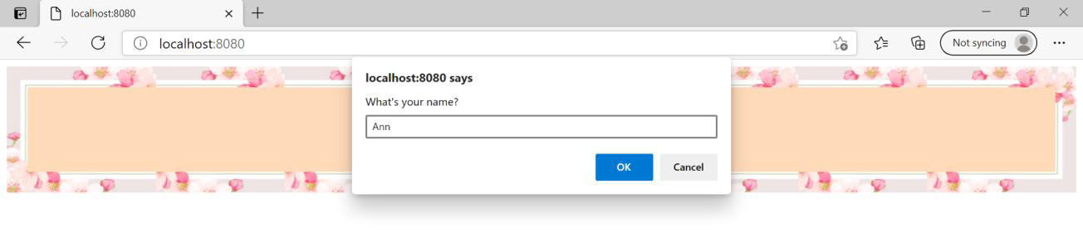











**Result:** The above code was successfully executed to implement a chat application with multiple rooms using node and express.

**Exercise 12**

**Date:** 14/06/2022

**Aim**

To create a calculator application using RESTful web services

**Code:**

**Calc.html**

<!DOCTYPE html>

<html lang="en">

<head>

<meta charset="UTF-8">

<meta http-equiv="X-UA-Compatible" content="IE=edge">

<meta name="viewport" content="width=device-width, initial-scale=1.0">

<title>Calculator</title>

<script src="https://ajax.googleapis.com/ajax/libs/angularjs/1.8.2/angular.min.js"></script>

</head>

<body>

<center>

<h3 id='bordering' style="background-color:peachpuff; width: 300px;">SIMPLE CALCULATOR</h3>

<div ng-app="CalculatorApp" ngcontroller="CalculatorController" id='bordering'

style="background-color:peachpuff;width: 300px">

<p>Operand 1</p>

<p><input type="number" ng-model="first"></p>

<p>Operand 2</p>

<p><input type="number" ng-model="second"></p>

<p>Choose operation</p>

<p><select ng-model="operator">

<option value="add">+</option>

<option value="subtract">-</option>

<option value="multiply">*</option>

<option value="divide">/</option>

</select></p>

<button ng-click="calculate()">CALCULATE</button>

<p>ANSWER</p>

<p ng-model="answer">{{answer}}</p>

</div>

</center>

<script>

angular.module('CalculatorApp', [])

.controller('CalculatorController', function ($scope, $http) {

$scope.calculate = function () {

ops = "/" + $scope.operator;

$http.get(ops,

{

params: {

first: $scope.first,

second: $scope.second

}

}).success(function (res) {

console.log('Exit status ' + JSON.stringify(res));

$scope.answer = res.result;

});

};

});

</script>

</body>

</html>

**Calchost.js**

const express = require("express");

const app = express();

app.use(express.static("public"));

app.get("/", (req, res) => {

res.sendFile(__dirname + "/Calc.html");

});

app.get("/add", (req, res) => {

var first = req.query.first;

var second = req.query.second;

var value = Number(first) + Number(second);

var result = { result: value };

res.send(result);

});

app.get("/subtract", (req, res) => {

var first = req.query.first;

var second = req.query.second;

var value = Number(first) - Number(second);

var result = { result: value };

res.send(result);

});

app.get("/multiply", (req, res) => {

var first = req.query.first;

var second = req.query.second;

var value = Number(first) * Number(second);

var result = { result: value };

res.send(result);

});

app.get("/divide", (req, res) => {

var first = req.query.first;

var second = req.query.second;

var value = Number(first) / Number(second);

var result = { result: value };

res.send(result);

});

app.listen(7000);

**Output:**

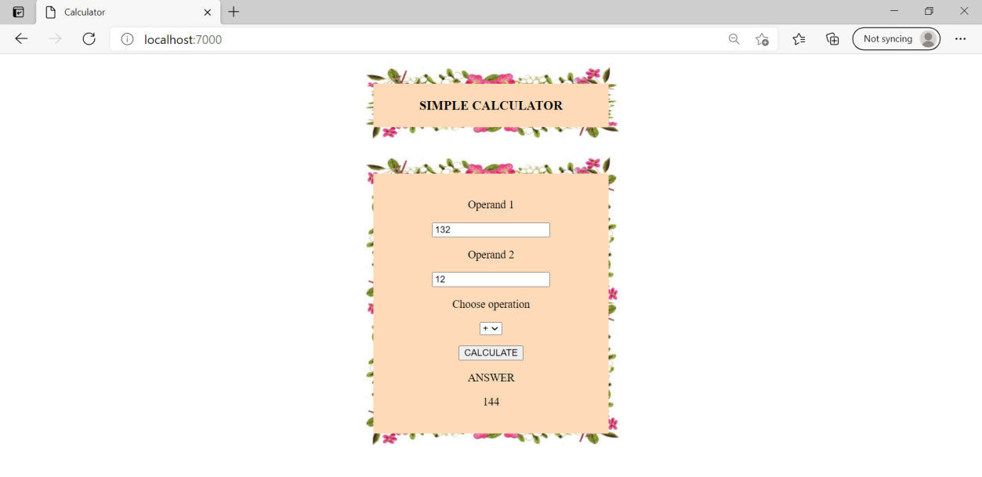

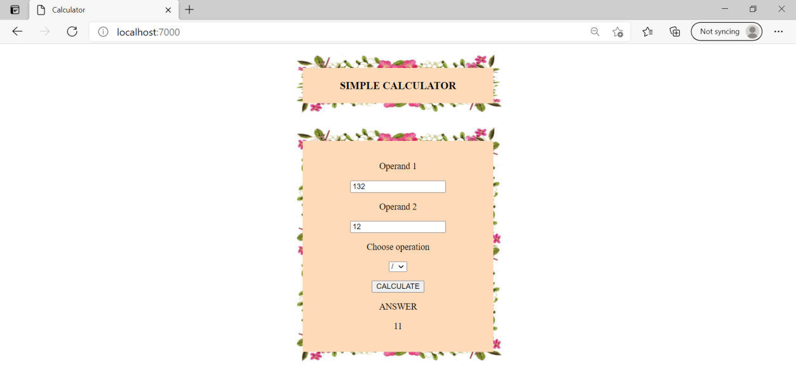

**Result:** The above code was successfully executed to implement simple calculator using RESTFUL web services.